**Environment (Wales) Act 2016 Part 1 – Section 6**

**The Biodiversity and Resilience of Ecosystems Duty**

**Biodiversity Action Plan for Town and Community Councils**

|  |  |  |
| --- | --- | --- |
| **Name of Town or Community Council:** | Rossett Community Council | |
| **Council type** **(Group 1, 2 or 3 for NRAP Objectives):** | | Group 2 |
| **Introduction and Context** | | |
| **The Community of Rossett is made up of the villages of Rossett itself, Burton, Lavister and Trevalyn. The population is approximately 3,500. There are currently just under 1400 houses in the area.**  **It is situated in the Wrexham County Borough Council area, almost equidistant between Wrexham and Chester.**  **The Council employs 4 members of staff including two Wardens, one for the Parks and one Street Warden.**  **The Community Council comprises of two electoral wards with a total of 14 Councillors.**  **The Precept for the current year is £68,000.**  **The following are located within the Community Council boundary:**   * **There are 3 equipped play areas of different sizes covering approximately 9000m2. These are overseen and maintained on a daily basis by the Wardens but are inspected regularly by Wrexham County Borough Council via a service level agreement.** * **The river Alyn runs through both wards and includes the Weir in Burton.** * **There are two village halls available to the community. Rossett Village Hall is currently run by a management committee consisting of members of the community. The other is the Presbyterian Church Hall, which also holds the pop-up post office for the community once a week.** * **The Community Agent for Rossett organises and runs a weekly Community Café for the older members of the community to come together and socialise. This is always well attended by locals from the community and volunteers to help run the morning.** * **Various other supportive agencies are located within the community e.g. a G.P practice, dental facilities and a pharmacy.** * **The Council are currently supporting the build of a Hub for the community with planning secured and building options being decided.** | | |
|  | | |

|  |  |  |  |  |
| --- | --- | --- | --- | --- |
| NRAP  Objective | **Biodiversity objectives** | **Action planned** | **Time scale** | **Monitored by:** |
| **1** | **-embed biodiversity into decision making & procurement** | We will continue to consider biodiversity in planning applications  Encourage use of environmentally friendly materials when supporting the Hwb’s new green/park areas being built/planted.  Go paperless wherever possible – not printing out documents and keeping more on-line | Ongoing  In line with the Hwb’s timescale  Ongoing | Clerk, RCC  RCC, Clerk, Hwb board  Clerk |
| **1** | **-raise awareness of biodiversity & its importance** | We will continue to support schemes showing awareness of biodiversity including the Bee Friendly Scheme and No Mow May  Posting information regularly on social media, RCC website and RCC public noticeboards | Yearly  Ongoing | Clerk  Clerk, RCC |
| **2** | **-safeguard principal species and habitats** | We will endeavour to continue planting native plants from the Welsh Government Planting for Pollinators guidance around the village planters.  We will continue to keep trimming of hedgerows to the correct times of the year in line with nesting seasons. | Seasonal  Seasonal | Clerk/RCC  Clerk |
| **3** | **-restore & create habitats and resilient ecological networks** | We will investigate the use of Water Butts/Suds Gardens to utilise natural falling water for gardening purposes rather than tap water.  Continuing to nurture the wildflower gardens and look into the introduction of bee and bug hotels in more of our green spaces.  Creating a wildflower border around the lands at Mountain View Play area green space. | April 24  April 24  Summer 23 | Clerk  Clerk  Clerk, RCC |
| **4** | **-tackle negative factors: for e.g. reduce pollution, use nature based solutions, address invasive species** | We will endeavour to get the Speed Awareness Scheme that is looking to be started, up and running in order to help reduce air pollution further. | September 23 | Clerk, RCC |
| **5** | **-use, improve, and share evidence** | Continuing to report damage to the environment including littering and how it is dealt with.  We will look into record keeping through apps such as LERC and COFNOD to help share evidence.  We will add Biodiversity to the agendas on occasions to keep regular updates on matters, which will then be minute-ed for general public viewing. | Ongoing  September 23  Every 3 months | Clerk, RCC  Clerk  Clerk |
| **6** | **-support capacity and/or other organisations** | Continuing to support local organisations who care for biodiversity friendly projects.  We will provide donations within our Donation Scheme (Section 137) to encourage work done by local groups that support biodiversity | Ongoing  September-November 23 | Clerk, RCC  Clerk, RCC |

|  |  |  |  |  |
| --- | --- | --- | --- | --- |
|  | | |  |  |
| **Annual review of the Biodiversity Action Plan** | | | **Date reviewed:** |  |
| **What has worked well?** |  | | | |
| **What have the barriers been?** |  | | | |
| **What will you change?** |  | | | |
|  | |  | | |
| **Next review due:** |  |  | | |
| **Approved by Council on:** |  |  | | |

**Deddf yr Amgylchedd (Cymru) 2016 Rhan 1 – Adran 6**

**Y Ddyletswydd Bioamrywiaeth a Chydnerthedd Ecosystemau**

**Cynllun Gweithredu Bioamrywiaeth ar gyfer Cynghorau Cymuned a Thref**

|  |  |  |
| --- | --- | --- |
| **Enw’r Cyngor Tref neu Gymuned:** |  | |
| **Math o gyngor** **(Grŵp 1,2, neu 3 ar gyfer amcan NRAP)** | |  |
| **Cyflwyniad a'r Cyd-destun** | | |
| *Disgrifiad byr o'r Cyngor, ei swyddogaethau a'r cyd-destun o ran:*   * *sut y gallai helpu bioamrywiaeth (trwy ei swyddogaethau rheoli tir, cyllid grant, gweithgareddau addysgol e.e.).* * *graddfa ofodol a lle (e.e. faint o dir mae'n ei gynnwys, poblogaeth, praesept?).* * *cyflawni gwasanaethau i'r cyhoedd (e.e. a yw gofynion Deddf Llesiant Cenedlaethau'r Dyfodol yn berthnasol iddo?).* | | |

|  |  |  |  |  |
| --- | --- | --- | --- | --- |
| Amcan  NRAP | **Amcan Bioamrywiaeth** | **Action planned** | **Time scale** | **Monitored by:** |
| **1** | **-cynnwys bioamrywiaeth o fewn llunio penderfyniadau a chaffael** |  |  |  |
| **1** | **-codi ymwybyddiaeth o fioamrywiaeth a'i bwysigrwydd** |  |  |  |
| **2** | **-diogelu prif rywogaethau a chynefinoedd** |  |  |  |
| **3** | **-adfer & chreu cynefinoedd a rhwydweithiau ecolegol cydnerth** |  |  |  |
| **4** | **-mynd i'r afael ag elfennau negyddol: lleihau llygredd e.e. defnyddio atebion yn seiliedig ar natur, mynd i'r afael â rhywogaethau goresgynnol** |  |  |  |
| **5** | **-defnyddio gwella a rhannu tystiolaeth** |  |  |  |
| **6** | **-cefnogi capasiti a/neu sefydliadau eraill** |  |  |  |

|  |  |  |  |  |
| --- | --- | --- | --- | --- |
|  | | | | |
| **Adolygiad blynyddol o’r Cynllun Gweithredu Bioamrywiaeth** | | | **Dyddiad yr adolygiad:** |  |
| **Beth sydd wedi gweithio'n dda?** |  | | | |
| **Beth fu'r rhwystrau?** |  | | | |
| **Beth fyddwch yn ei newid?** |  | | | |
|  | |  | | |
| **Dyddiad yr adolygiad nesaf:** |  |  | | |
| **Cymeradwywyd gan y Cyngor ar:** |  |  | | |

Back

The **Nature Recovery Action Plan for Wales (NRAP**) sets out six objectives  for reversing the decline of biodiversity which should be used to help develop  and guide actions to comply with the section 6 duty:   
The 6 objectives to maintain and enhance biodiversity are:

**Objective 1**: Engage and support participation and understanding to embed  biodiversity throughout decision making at all levels

**Objective 2**: Safeguard species and habitats of principal importance and improve their management

**Objective 3**: Increase the resilience of our natural environment by restoring degraded habitats and habitat creation

**Objective 4**: Tackle key pressures on species and habitats

**Objective 5**: Improve our evidence, understanding and monitoring

**Objective 6**: Put in place a framework of governance and support for delivery

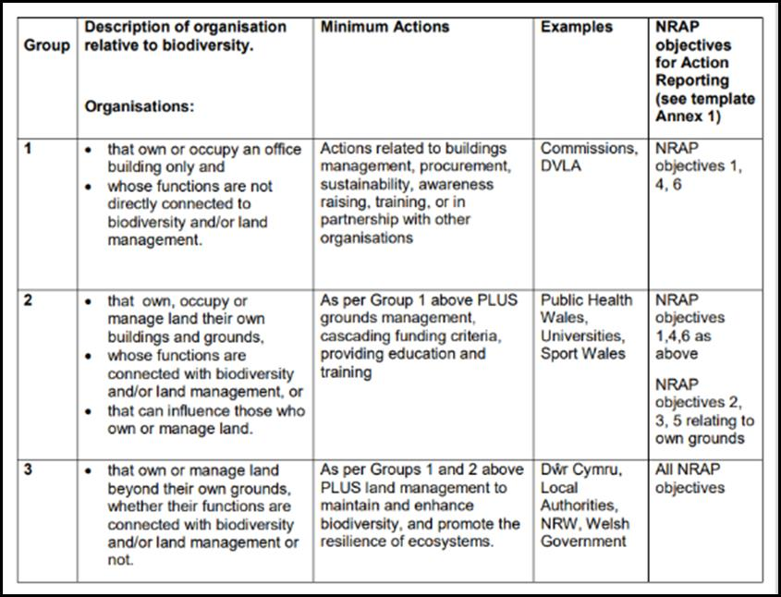

Nôl

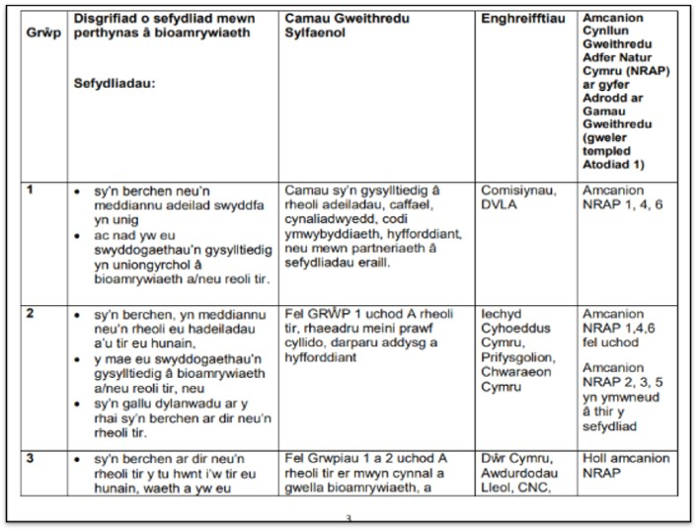

Mae **Cynllun Gweithredu Adfer Natur Cymru (NRAP)** yn cyflwyno chwe amcan ar gyfer dadwneud colli bioamrywiaeth, a dylid eu defnyddio i helpu datblygu a llywio gweithredoedd i gydymffurfio â dyletswydd adran 6:   
Y 6 amcan i gynnal a chryfhau bioamrywiaeth yw:

**Amcan 1**: Ennyn a chefnogi cyfranogiad a dealltwriaeth er mwyn i fioamrywiaeth fwrw gwreiddiau yn y broses benderfynu ar bob lefel.

**Amcan 2**: Diogelu rhywogaethau a chynefinoedd sydd o’r pwys mwyaf a’u rheoli’n well.

**Amcan 3**: Gwneud ein hamgylchedd naturiol yn fwy cydnerth drwy adfer cynefinoedd sydd wedi'u diraddio a chreu cynefinoedd.

**Amcan 4**: Mynd i’r afael â’r prif bwysau ar rywogaethau a chynefinoedd.

**Amcan 5**: Gwella ein tystiolaeth, ein dealltwriaeth a’n gwaith monitro

**Amcan 6**: Rhoi fframwaith llywodraethu a chymorth ar waith i gyflawni’r amcanion.