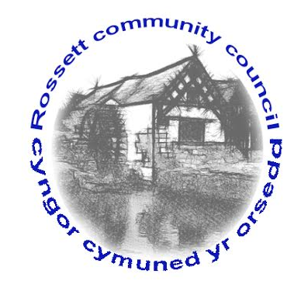
ROSSETT COMMUNITY COUNCIL

Local Government (Wales) Measure 2011, Section 116
Notice of Co-Option

NOTICE IS HEREBY GIVEN that the Rossett Community Council intends to Co-opt two member(s) to fill the vacancies that exist in the office of Councillor for the Allington Town/Community (Ward).

Expressions of interest are being sought from members of the public who meet the following qualifications and are interested in representing their community on the aforementioned Community Council. You must be a British citizen, an eligible Commonwealth citizen, a citizen of any member state of the European Union or a qualifying foreign citizen and be 18 years of age or over; and meet at least one of the following criteria:

- registered as a local government elector for the area named above; or
- during the whole of the last 12 months occupied as owner or tenant land or other premises in the community named above; or
- your principal or only place of work during the last 12 months has been in the community named above; or
- you have during the whole of the last 12 months resided in the Commuinity or with 4.8 kilometres of it.

If you wish to be considered for co-option for the vacant seats(s) or want more information regarding the role of a Town/Community Councillor please contact the Proper Officer, Clerk to the Council at clerk@rossettcommunitycouncil.cymru by Friday 10th June 2022

Dated this 29th day of May 2022

Certain people are disqualified from standing, and these include paid officers of the community council, anyone subject to bankruptcy restriction orders and those subject to recent sentences of imprisonment.

