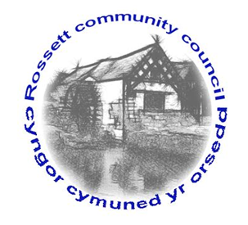

Community Speed Watch Scheme

Rossett Community Council are searching for volunteers for a potential Speed Watch Scheme

We are in need of 1 co-ordinator and 2 other operators for the scheme to go ahead.
Minimum age for volunteers is 18 years
Please email clerk@rossettcommunitycouncil.cymru if you would be interested in helping

