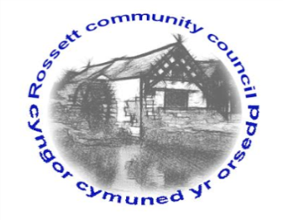

Rossett Community Council

11th September 2020

The next meeting of Rossett Community Council is to be held via video conferencing on Wednesday 16th September 2020 at 7.30pm to transact the following business.

Yours faithfully

Wendy Pace
Clerk for the Council
AGENDA

Declarations of Interest
Members are reminded that they should declare the existence and nature of any personal or prejudicial interest in the business of this meeting.

- Apologies for absence.

- Approval of the Minutes of the 19th August 2020 meeting.

- Representation's from General Public

- Matters Arising

- Hwb Yr Orsedd
- Trevalyn Way Possessory Title - Clerk

5. Matters to be discussed:

- NJC Pay Award – Clerk
- Risk Assessment/Policy Review – Cllr Woods

6. Reports: To receive updates from the following:

- County Councillor Jones’ Report
- Clerk’s Report
- Reports from Community Councillors

7. Planning:

P/2020/0448 – Orchard House, Trevalyn Manor, Manor Lane, Rossett – Listed Building Consent for Sun Room (amendments to Listed Building Consent P/2012/0511).

P/2020/0450 – Briarley, Burton Road, Rossett – Alterations to Vehicular Access.

P/2020/0496 – Alynfield Cottage, Harwoods Lane, Rossett - Conversion of Single-Storey Poolhouse into Two Storey Extension.

P/2020/0520 – The Stone House, Llay Road, Burton, Rossett – Proposed Outdoor Swimming Pool.

P/2020/0538 – Highclere, Burton Road, Burton, Rossett – Two-Storey Side and Rear Extension and New Dormer Windows to Front.

8. Finance:
- Finance Report
- Invoices payable (see attached schedule)

9. Other Items brought to the Council’s Attention by Councillors

10. Date, Venue and Time of next meeting: Wednesday 21st October 2020 at 7.30pm at Rossett Village Hall, Station Road.
_____________________________________________________________
Clerk : Wendy Pace : clerk@rossettcommunitycouncil.cymru Tel: 07421 261118

Due to Covid 19 a public meeting cannot be held. Members of the community are invited to forward any issues for discussion via email or telephone to the Clerk. If you would like to view the meeting, please email the Clerk to request the meeting ID.

