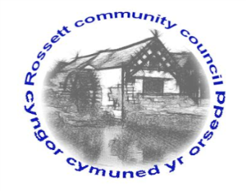

Rossett Community Council

15th August 2020

The next meeting of Rossett Community Council is to be held via video conferencing on Wednesday 19th August 2020 at 7.30pm to transact the following business.

Yours faithfully

Wendy Pace
Clerk for the Council
AGENDA

Declarations of Interest
Members are reminded that they should declare the existence and nature of any personal or prejudicial interest in the business of this meeting.

- Apologies for absence.

- Approval of the Minutes of the 15th July 2020 meeting.

- Representation's from General Public

- Matters Arising

- Hwb Yr Orsedd – Lease agreement

5. Matters to be discussed:

- Litter Signs – Cllr Steven
- Park Warden vacancy – Clerk
- Playground gate
- Bellis Development Access Points - Clerk

6. Reports: To receive updates from the following:

- County Councillor Jones’ Report
- Clerk’s Report
- Reports from Community Councillors

7. Planning:

P/2020/0320 – Land at Home Farm, Gresford Road, Llay – Approval of Reserved Matters Pursuant to Outline Planning Permission P/2014/0905 – Access Appearance, Landscaping, Layout and Scale in respect of phases A2A, A3A and A7A for the Erection of 11 Market Dwellings and 8 Affordable Dwellings (Amendment Plans).

P/2020/0324 – Wynona, Station Road, Rossett – To Fell 1 Sycamore and 2 Ash Trees in a Conservation Area.

P/2020/0327 – Trevalyn Hall, Trevalyn Wood, Manor Lane, Rossett – Extension, Alterations, Landscaping and Erection of Storage Building.

P/2020/0328 – Trevalyn Hall, Trevalyn Wood, Manor Lane, Rossett – Listed Building Consent for Extension, Internal and External Alterations and Landscaping.

P/2020/0396 – Mill Brook Cottage, Mill Yard, Chester Road, Rossett – Works to Sycamore Tree Protected by TPO NO. 216.

P/2020/0417 – Bodalyn, Chester Road, Rossett – Notification of Proposed Works to Copper Beech Tree within Rossett Conservation Area.

8. Finance:
- Finance Report
- Invoices payable (see attached schedule)

9. Other Items brought to the Council’s Attention by Councillors

10. Date, Venue and Time of next meeting: Wednesday 16th September 2020 at 7.30pm at Rossett Village Hall, Station Road.
_____________________________________________________________
Clerk : Wendy Pace : clerk@rossettcommunitycouncil.cymru Tel: 07421 261118

Due to Covid 19 a public meeting cannot be held. Members of the community are invited to forward any issues for discussion via email or telephone to the Clerk. If you would like to view the meeting, please email the Clerk to request the meeting ID.

