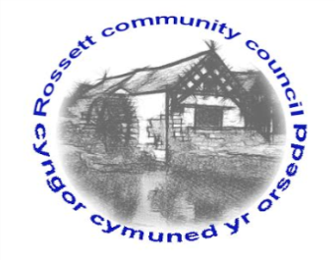

Rossett Community Council

14th October 2020

The next meeting of Rossett Community Council is to be held via video conferencing on Wednesday 21st October 2020 at 7.30pm to transact the following business.

Yours faithfully

Wendy Pace
Clerk for the Council
AGENDA

Declarations of Interest
Members are reminded that they should declare the existence and nature of any personal or prejudicial interest in the business of this meeting.

- Apologies for absence.

- Approval of the Minutes of the 16th September 2020 meeting.

- Representation's from General Public

- Matters Arising

- Hwb Yr Orsedd

5. Matters to be discussed:

- Autumn Activities – Cllr Parrington
- Remembrance Service - Clerk

6. Reports: To receive updates from the following:

- County Councillor Jones’ Report
- Clerk’s Report
- Reports from Community Councillors

7. Planning:

P/2020/0538 – Highclere, Burton Road, Burton, Rossett – Amended Plans for Two-Storey Side and Rear Extension and New Dormer Windows to Front.

P/2020/0559 – The Stone House, Llay Road, Burton, Rossett – Listed Building Consent for Alterations to Coach House to Provide Shower Area and Bedroom/Living Area Above.

P/2020/0626 – 5 Halkyn Terrace, Chester Road, Rossett – Dismantle and Rebuild Boundary Wall Using Existing Bricks plus Coping Stones, Removal of Rear Structure and Erection of Replacement Shed (Partly in Retrospect).

P/2020/0644 – Lakeside, Stoneleigh, Rossett – Works to Trees Protected by TPO WCBC No 97.

8. Finance:
- Finance Report
- Invoices payable (see attached schedule)
- Donations

9. Other Items brought to the Council’s Attention by Councillors

10. Date, Venue and Time of next meeting: Wednesday 18th November 2020 at 7.30pm via video conferencing.
_____________________________________________________________
Clerk : Wendy Pace : clerk@rossettcommunitycouncil.cymru Tel: 07421 261118

Due to Covid 19 a public meeting cannot be held. Members of the community are invited to forward any issues for discussion via email or telephone to the Clerk. If you would like to view the meeting, please email the Clerk to request the meeting ID.

