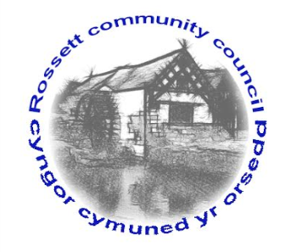

Rossett Community Council

10th November 2016

The next meeting of Rossett Community Council is to be held at Rossett Presbyterian Church, Station Road, Rossett on Wednesday 16th November 2016 at 7.30pm to transact the following business.

Yours faithfully

Sarah Tushingham

Clerk for the Council
AGENDA

Declarations of Interest
Members are reminded that they should declare the existence and nature of any personal or prejudicial interest in the business of this meeting.

- Apologies for absence.

- Welcome to new Councillors.

- Approval of the Minutes of the 21st September 2016 meeting.

- Police Report.

- Matters arising:

- Update on CCTV project (Cllr. G Smith);
- Update on toilet block community project (Cllr. C Guest);
- Update on Youth Representation Scheme (Cllr. C Guest);
- Floral topping for mini-roundabout topping;
- Greenfields playing field (Cllr. Montgomery);
- Update on Christmas tree lights event (Cllr. A Parrington);
- Update on Health & Safety Policy and Risk Assessment
Policy of all recreation grounds (Cllr. Montgomery);
- Matters to be discussed:

- Finance Committee membership;
- Donations;
- Precept planning and external Auditor recommendations;
- New park signs;
- Parking restrictions outside the large gate to the park;
- Community Speed Watch Team (Cllr. Hugh Jones);
- Return to monthly meetings;
- Staff minimum/living wage (Cllr. A Parrington);
- Youth Support Services;
- One Voice Wales representative;
- Replacement noticeboards.

6. Reports : To receive updates from the following:

- County Councillor Jones’ Report (copy attached)
- Clerk’s Report (copy attached)
- Parks and Recreation sub-committee Report (awaited)
- Flood Committee Report (Cllr. C Parker);
- Reports from Community Councillors

7. Planning : The following Planning Applications have been received since the last meeting:

P/2016/0890 : Rossalyn, Llay Road – No objection
P/2015/0713 : Appeal – Lower Parks Farm – No objection
P/2016/0907 : Trevalyn Wood, Manor Lane – No objection
P/2016/0875 : Chapel Cottage, Rossett – No objection

8. Finance:

- Financial position October 2016;
- Invoices payable (see attached schedule)

9. Any other business.

10. Date, Venue and Time of next meeting : Wednesday [ ] December 2016 at 7.30pm at the Presbyterian Church, Station Road, Rossett.
_____________________________________________________________

Clerk : Sarah Tushingham : clerk@rossettcommunitycouncil.cymru

