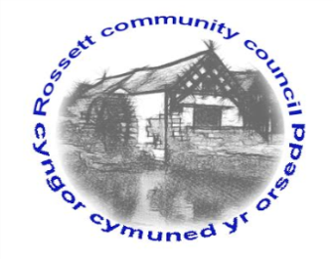

Rossett Community Council

11th February 2021

The next meeting of Rossett Community Council is to be held via video conferencing on Wednesday 17th February 2021 at 7.30pm to transact the following business.

Wendy Pace
Clerk for the Council
AGENDA

Declarations of Interest
Members are reminded that they should declare the existence and nature of any personal or prejudicial interest in the business of this meeting.

- Apologies for absence

- Approval of the Minutes of the 20th January 2021 meeting

- Crime Report

- Representation's from General Public
- Street Lighting Llyndir Lane
- Harwoods Lane/Trevalyn Way Road surfaces
- Bridges – Cllr Maurice-Jones

- Matters Arising
- Hwb Yr Orsedd
- Flooding
- Youth Representative

6. Matters to be discussed:
- Ground Maintenance Contract – Clerk
- Straight Mile Footpath – Cllr Parrington
- Memorial Garden Donation - Clerk

7. Reports: To receive updates from the following:
- County Councillor Jones’ Report
- Clerk’s Report
- Reports from Community Councillors

8. Finance:
- Finance Report
- Invoices payable (see attached schedule)
- Internal Audit

9. Planning:

P/2021/0005 – Coxwood Farm, Cox Lane, Rossett– Construction of Agricultural Workers Dwelling and Garage.

P/2021/0037 – Rossett Park, The Green, Rossett – Demolition of Disused Toilet Block and Construction of New Community Hub with Internal works.

P/2021/0038 – Rossett Park, The Green, Rossett – Conservation Area Consent for Demolition of Disused Toilet Block.

10. Other Items brought to the Council’s Attention by Councillors

11. Date, Venue and Time of next meeting: Wednesday 17th March 2021 at 7.30pm via video conferencing.
_____________________________________________________________
Clerk : Wendy Pace : clerk@rossettcommunitycouncil.cymru Tel: 07421 261118

Due to Covid 19 a public meeting cannot be held. Members of the community are invited to forward any issues for discussion via email or telephone to the Clerk. If you would like to view the meeting, please email the Clerk to request the meeting ID.

