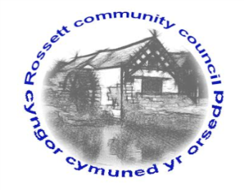

Rossett Community Council

11th March 2021

The next meeting of Rossett Community Council is to be held via video conferencing on Wednesday 17th March 2021 at 7.30pm to transact the following business.

Wendy Pace
Clerk for the Council
AGENDA

Declarations of Interest
Members are reminded that they should declare the existence and nature of any personal or prejudicial interest in the business of this meeting.

- Apologies for absence

- Approval of the Minutes of the 17th February 2021 meeting

- Crime Report

- Representation's from General Public
- Darland Field – Cllr Steven

- Matters Arising
- Hwb Yr Orsedd

- Matters to be discussed:
(i) Rossett Hub Complaint – Cllr Parrington

7. Reports: To receive updates from the following:
- County Councillor Jones’ Report
- Clerk’s Report
- Reports from Community Councillors

8. Finance:
- Finance Report
- Invoices payable (see attached schedule)

9. Planning:

P/2021/0075 – Christ Church, 3 The Copse, Rossett – Works to Trees within the Conservation Area, Fell G4 Graveyard, Fell T10 Churchyard – Reduce back to Boundary by 1.0M - Comments requested by 05/03/21.

P/2021/0078 – Coach House, Llay Road, Rossett – Works to Yew Tree Protected by TPO.

P/2021/0085 – Rosemary Cottage, Rosemary Lane, Burton, Rossett – Single Storey Rear Extension - Comments requested by 05/03/21.

P/2021/0110 – Land to the North and South of Lane Farm, Rossett Road, Trevalyn, Rossett – Reserved Matters (Associated Works) Pursuant to Outline Planning Application P/2018/0560.

P/2021/0153 – Three Acres, Rosemary Lane, Burton, Rossett – Single Storey and Two Storey Side Extensions and Single Storey Front Extension.

P/2020/0882 – Hem House Cottage, Rossett Road, Parkside, Rossett – Erection of Detached Single Storey Granny Annexe

10. Other Items brought to the Council’s Attention by Councillors

11. Date, Venue and Time of next meeting: Wednesday 21st April 2021 at 7.30pm via video conferencing.
_____________________________________________________________
Clerk : Wendy Pace : clerk@rossettcommunitycouncil.cymru Tel: 07421 261118

Due to Covid 19 a public meeting cannot be held. Members of the community are invited to forward any issues for discussion via email or telephone to the Clerk. If you would like to view the meeting, please email the Clerk to request the meeting ID.

