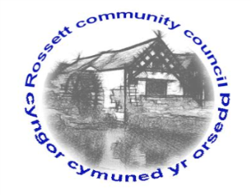

Rossett Community Council

15th April 2021

The next meeting of Rossett Community Council is to be held via video conferencing on Wednesday 21st April 2021 at 7.30pm to transact the following business.

Wendy Pace
Clerk for the Council
AGENDA

Declarations of Interest
Members are reminded that they should declare the existence and nature of any personal or prejudicial interest in the business of this meeting.

- Apologies for absence

- Approval of the Minutes of the 17th March 2021 meeting

- Crime Report

- Representation's from General Public
- Harwoods Lane resurfacing – Jeff Peet
- Overflowing bins – Jeff Peet

- Matters Arising
- Hwb Yr Orsedd

- Matters to be discussed:

7. Reports: To receive updates from the following:
- County Councillor Jones’ Report
- Clerk’s Report
- Reports from Community Councillors

8. Finance:
- Finance Report
- Invoices payable (see attached schedule)

9. Planning:

P/2021/0253 – The Old School House, Burton Green, Rossett – First Floor Rear Extension and New Entrance Gate - Comments requested by 09/04/21.

P/2021/0070 – Trevalyn Court, Chester Road, Rossett – Listed Building Consent for Retention of Temporary Partition – Comments requested by 12/04/21.

P/2021/0274 – Golden Lion Hotel, Chester Road, Rossett – Erection of Tipi for a Temporary Period of 3 Years.

P/2021/0284 – Ravenoak, Broad Lane, Rossett – Two Storey Rear, First Floor Side and Front Porch Extensions.

P/2021/0303 – 9 Easton Close, Rossett – Single Storey Rear Extension.

P/2020/0819 – Wynona, Station Road, Rossett – Amended Plans – Erection of Detached Dwelling.

P/2021/0293 – Gamford House, Gamford Lane, Rossett – Application for a Lawful Development Certificate for an Existing Use or Operation.

P/2021/0315 – 1 Lower Parkside Cottages, Parkside, Rossett – Demolition of Existing Outrigger and Erection of Two Storey Side and Rear Extensions and Detached Garage.

P/2021/0316 – 2 Lower Parkside Cottages, Parkside, Rossett – Demolition of Existing Outrigger and Erection of Two Storey Side and Rear Extensions and Detached Garage.

P/2021/0317 – 18 Stonewalls, Burton, Rossett – Single Storey Rear Extension.

10. Other Items brought to the Council’s Attention by Councillors

11. Date, Venue and Time of next meeting: Wednesday 19th May 2021 at 7.30pm via video conferencing.
_____________________________________________________________
Clerk : Wendy Pace : clerk@rossettcommunitycouncil.cymru Tel: 07421 261118

Due to Covid 19 a public meeting cannot be held. Members of the community are invited to forward any issues for discussion via email or telephone to the Clerk. If you would like to view the meeting, please email the Clerk to request the meeting ID.

