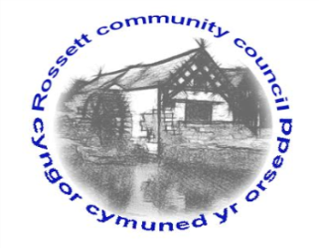

Rossett Community Council
12th August 2021

The next meeting of Rossett Community Council is to be held via video conferencing on Wednesday 18th August 2021 at 7.30pm to transact the following business.

Wendy Pace
Clerk for the Council
AGENDA

Declarations of Interest
Members are reminded that they should declare the existence and nature of any personal or prejudicial interest in the business of this meeting.

- Apologies for absence

- Approval of the Minutes of the 21st July 2021 meeting

- Crime Report

- Representation's from General Public

- Matters Arising
- Hwb Yr Orsedd

- Matters to be discussed:
- Traffic proposal - The Green
- Burton Public Footpaths – Cllr Parrington

7. Reports: To receive updates from the following:
- County Councillor Jones’ Report
- Clerk’s Report
- Reports from Community Councillors

8. Finance:
- Finance Report
- Invoices payable (see attached schedule)

9. Planning:

P/2021/0741 – Lodge Farm, Borras Road, Commonwood, Holt – Change of Use of Agricultural Building to Indoor Rifle Range (In Retrospect).

10. Other Items brought to the Council’s Attention by Councillors

11. Date, Venue and Time of next meeting: Wednesday 15th September 2021 at 7.30pm via video conferencing.
_____________________________________________________________
Clerk : Wendy Pace : clerk@rossettcommunitycouncil.cymru Tel: 07421 261118

Due to Covid 19 a public meeting cannot be held. Members of the community are invited to forward any issues for discussion via email or telephone to the Clerk. If you would like to view the meeting, please email the Clerk to request the meeting ID.

