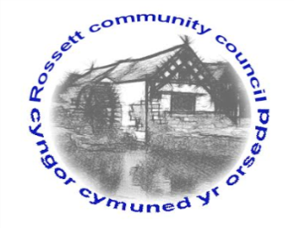

Rossett Community Council
15th July 2021

The next meeting of Rossett Community Council is to be held via video conferencing on Wednesday 21st July 2021 at 7.30pm to transact the following business.

Wendy Pace
Clerk for the Council
AGENDA

Declarations of Interest
Members are reminded that they should declare the existence and nature of any personal or prejudicial interest in the business of this meeting.

- Apologies for absence

- Approval of the Minutes of the 16th June 2021 meeting

- Crime Report

- Representation's from General Public

- Matters Arising
- Hwb Yr Orsedd

- Matters to be discussed:
- Funding raising for Church- Cllr Parrington
- Parkside Planter – Cllr Parrington
- Rossett Virtual Festival – Cllr Fortune
- 1st Rossett Scout Group - signage

7. Reports: To receive updates from the following:
- County Councillor Jones’ Report
- Clerk’s Report
- Reports from Community Councillors

8. Finance:
- Finance Report
- Invoices payable (see attached schedule)

9. Planning:

P/2021/0478 – Avalon, Chester Road, Rossett – Two Storey Side Extension and Detached Garage - Comments requested by 9/07/21.
P/2021/0479 – Newlyn, Chester Road, Rossett – Two Storey Side Extension and Detached Garage - Comments requested by 9/07/21.

P/2021/0486 – Ballswood Quarry, Gegin Lane, Llay – Variation of Conditions 01 and 03 of Planning Permission P/2016/0110 To Change Limits of Extraction Within Permitted Quarry Boundary.

P/2021/0611 – Land at Mill Brook Close, Lavister – Outline Application (All Matters Reserved) For up to 7 Dwellings

P/2021/0613 – Manor Lodge, Trevalyn Manor, Manor Lane, Rossett – Single Storey Extension and Installation of Roof Lights.

P/2021/0614 – Manor Lodge, Trevalyn Manor, Manor Lane, Rossett – Listed Building Consent for Single Storey Extension and Installation of Roof Lights.

P/2021/0664 – 2 West Way, Rossett – Single Storey Side Extension.

P/2021/0671 – Tycaed, Broad Lane, Trevalyn, Rossett – First Floor Side Extension and Erection of Boundary Wall and Fence.

10. Other Items brought to the Council’s Attention by Councillors

11. Date, Venue and Time of next meeting: Wednesday 18th August 2021 at 7.30pm via video conferencing.
_____________________________________________________________
Clerk : Wendy Pace : clerk@rossettcommunitycouncil.cymru Tel: 07421 261118

Due to Covid 19 a public meeting cannot be held. Members of the community are invited to forward any issues for discussion via email or telephone to the Clerk. If you would like to view the meeting, please email the Clerk to request the meeting ID.

