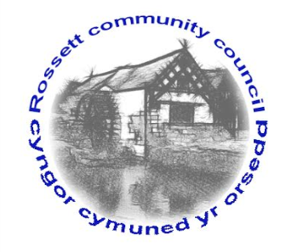

Rossett Community Council

15th December 2016

The next meeting of Rossett Community Council is to be held at Rossett Presbyterian Church, Station Road, Rossett on Wednesday 21st December 2016 at 7.30pm to transact the following business.

Yours faithfully

Sarah Tushingham

Clerk for the Council

AGENDA

Declarations of Interest
Members are reminded that they should declare the existence and nature of any personal or prejudicial interest in the business of this meeting.

- Apologies for absence.

- Approval of the Minutes of the 16 November 2016 meeting.

- Police Report.

- Matters arising:

- Update on CCTV project (Cllr. G Smith);
- Update on the Cadwyn Clwyd application re toilet block (Cllr. C Guest);
- Update on Health & Safety Policy and Risk Assessment
Policy of all recreation grounds (Cllr. Dolan);
- Review of Christmas tree event;
- Update on Finance Committee membership;
- Update on One Voice Wales representative.

- Matters to be discussed:

- Street Warden’s work program;
- Changes to the banking system : updating Financial Regulations;
- Mountain View replacement fencing;
- Street lighting in Station Road (Cllr. Jones);
- Review of lighting contractor (Cllr. Jones);
- Social media and website updates.

6. Reports : To receive updates from the following:

- County Councillor Jones’ Report
- Clerk’s Report (copy attached)
- Parks and Recreation sub-committee Report
- Reports from Community Councillors

7. Planning : No Planning Applications have been received since the last meeting.

8. Finance:

- Financial position November 2016;
- Invoices payable (see attached schedule)

9. Any other business.

10. Date, Venue and Time of next meeting : Wednesday [ ] January 2017 at 7.30pm at the Presbyterian Church, Station Road, Rossett.
_____________________________________________________________

Clerk : Sarah Tushingham : clerk@rossettcommunitycouncil.cymru

