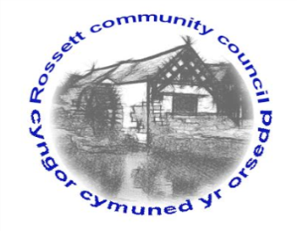

Rossett Community Council

10th September 2021

The next meeting of Rossett Community Council is to be held at Rossett Village Hall on Wednesday 15th September 2021 at 7.30pm to transact the following business.

Wendy Pace
Clerk for the Council
AGENDA

Declarations of Interest
Members are reminded that they should declare the existence and nature of any personal or prejudicial interest in the business of this meeting.

- Apologies for absence

- Approval of the Minutes of the 18th August 2021 meeting

- Crime Report

- Representation's from General Public

- Matters Arising
- Hwb Yr Orsedd

- Matters to be discussed:
- B5102 residents’ concerns – Cllr Jones

7. Reports: To receive updates from the following:
- County Councillor Jones’ Report
- Clerk’s Report
- Reports from Community Councillors

8. Finance:
- Finance Report
- Invoices payable (see attached schedule)
- Donations

9. Planning:

P/2021/0823 – Riverdale, Burton Road, Rossett – Single Storey Rear Extension – comments requested by 08/09/21.

P/2021/0874 – The Old Post Office, Station Road, Rossett – Change of Use of a Ground Floor Shop (Class A1), Including the Ground Floor of Associated Dwelling and Rear Garden (Class C3) To a Restaurant/Coffee Shop/Takeaway (Class A3), Internal Alterations to First Floor (Class C3).

10. Other Items brought to the Council’s Attention by Councillors

11. Date, Venue and Time of next meeting: Wednesday 20th October 2021 at 7.30pm at Rossett Village Hall.
_____________________________________________________________
Clerk : Wendy Pace : clerk@rossettcommunitycouncil.cymru Tel: 07421 261118

This meeting will be held in the Village Hall but can also be joined remotely. If you would like to view the meeting, please email the Clerk to request the meeting ID.

