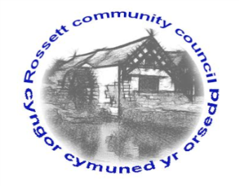

Rossett Community Council

12th November 2021

The next meeting of Rossett Community Council is to be held at Rossett Village Hall on Wednesday 17th October 2021 at 7.30pm to transact the following business.

Wendy Pace
Clerk for the Council
AGENDA

Declarations of Interest
Members are reminded that they should declare the existence and nature of any personal or prejudicial interest in the business of this meeting.

- Apologies for absence

- Approval of the Minutes of the 20th October 2021 meeting

- Crime Report

- Representation's from General Public

- Matters Arising
- Hwb Yr Orsedd
- Traffic Order – The Green

- Matters to be discussed:

7. Reports: To receive updates from the following:
- County Councillor Jones’ Report
- Clerk’s Report
- Reports from Community Councillors

8. Finance:
- Finance Report
- Invoices payable (see attached schedule)
- Community Donations

9. Planning:

P/2021/0992 – 2 Sunny Villas, Station Road, Rossett – Replacement of Front Door (comments requested by 12/11/21).

P/2021/0904 – Langdale, Chester Road, Rossett – Single Storey Rear Extension and Front Porch (comments requested by 12/11/21).

P/2021/1008 – The Coach House, Trevalyn Hall, Chester Road, Rossett – Listed Building Consent for Rear Two Storey Extension. Renewal of Listed Building Consent P/2016/0350.

P/2021/1009 - The Coach House, Trevalyn Hall, Chester Road, Rossett –Two Storey Extension. Renewal of Planning Permission P/2016/0351.

P/2021/01065 – Lilac Cottage, Stringers Lane, Burton, Rossett – Two Storey Front and Side Extensions.

ENQ/2021/0316 – Scoping Opinion Request – Ballswood Quarry, Gegin Lane, Llay – EIA Scoping Request

P/2021/0874 – The Old Post Office, Station road, Rossett – Change of Use of a Ground Floor Shop (Class A1) and Ground Floor of Associated Dwelling and Rear Garden (Class C3) to a Restaurant/Coffee Shop (Class A3) and Internal Alterations to the Existing Residential Use on the First Floor.

10. Other Items brought to the Council’s Attention by Councillors

11. Date, Venue and Time of next meeting: Wednesday 15th December 2021 at 7.30pm at Rossett Village Hall.
_____________________________________________________________
Clerk : Wendy Pace : clerk@rossettcommunitycouncil.cymru Tel: 07421 261118

This meeting will be held in the Village Hall but can also be joined remotely. If you would like to view the meeting, please email the Clerk to request the meeting ID.

