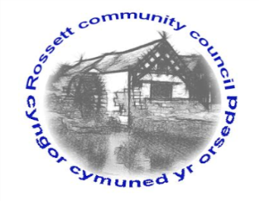

Rossett Community Council

15th October 2021

The next meeting of Rossett Community Council is to be held at Rossett Village Hall on Wednesday 20th October 2021 at 7.30pm to transact the following business.

Wendy Pace
Clerk for the Council
AGENDA

Declarations of Interest
Members are reminded that they should declare the existence and nature of any personal or prejudicial interest in the business of this meeting.

- Apologies for absence

- Approval of the Minutes of the 15th September 2021 meeting

- Crime Report

- Representation's from General Public
Burton Underpass – John Jorgensen

- Matters Arising
- Hwb Yr Orsedd
- Traffic Order – The Green

- Matters to be discussed:
- Festive illuminations – Cllr Gledhill
- Remembrance Service

7. Reports: To receive updates from the following:
- County Councillor Jones’ Report
- Clerk’s Report
- Reports from Community Councillors

8. Finance:
- Finance Report
- Invoices payable (see attached schedule)
- Councillor Allowance

9. Planning:

P/2020/0250 – The Coach House, Trevalyn Hall, Chester Road, Rossett – Erection of Garden Office, Relocation of Existing Garden Shed and Retention of Existing Garden Shed, Telephone Kiosk and Raised Tree House Style Decked Area.

P/2021/0904 – 5 Park View, Chester Road, Rossett – Dropping of Kerb to Access Existing Driveway (comments requested by 08/10/21).

P/2021/0949 – 1 Alyn Drive, Rossett – Single and First Floor Rear Extensions.

10. Other Items brought to the Council’s Attention by Councillors

11. Date, Venue and Time of next meeting: Wednesday 17th November 2021 at 7.30pm at Rossett Village Hall.
_____________________________________________________________
Clerk : Wendy Pace : clerk@rossettcommunitycouncil.cymru Tel: 07421 261118

This meeting will be held in the Village Hall but can also be joined remotely. If you would like to view the meeting, please email the Clerk to request the meeting ID.

