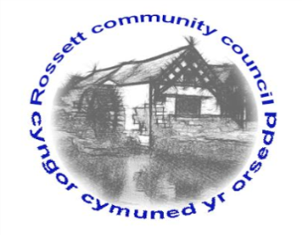

Rossett Community Council

14th January 2022

The next meeting of Rossett Community Council is to be held remotely via Zoom on Wednesday 19th January 2022 at 7.30pm to transact the following business.

Wendy Pace
Clerk for the Council
AGENDA

Declarations of Interest
Members are reminded that they should declare the existence and nature of any personal or prejudicial interest in the business of this meeting.

- Apologies for absence

- Approval of the Minutes of the 15th December 2021 meeting

- Crime Report

- Representation's from General Public
Mr John Jorgensen – Underpass
Mr John Filce – River Alyn debris

- Matters Arising
- Hwb Yr Orsedd
- Traffic Order – The Green

- Matters to be discussed:
- WCBC Play area SLA – Clerk
- City of Culture banners – Cllr Jones
- Gambling Licence – Clerk
- Scarecrow Festival – Cllr Parrington
- Equalities Policies – Cllr Parrington
- Williams Way – Cllr Parrington
- Village Hall – Cllr Parrington

7. Reports: To receive updates from the following:
- County Councillor Jones’ Report
- Clerk’s Report
- Reports from Community Councillors
- Youth Representative

8. Finance:
- Finance Report
- Invoices payable (see attached schedule)

9. Planning:

P/2021/1172 – Briarley, Burton Road, Burton, Rossett – Replacement of Existing Boot Room (comments requested by 5/1/22).

P/2022/0006 – Land at Trevalyn Manor, Manor Lane, Trevalyn, Rossett – Installation of Electric Vehicle Charging Points.

P/2022/0008 – Rossett Park, The Green, Rossett – Demolition of Disused Toilet Block and Construction of New Community Hub with Internal Works.

P/2022/0009 – Rossett Park, The Green, Rossett – Conservation Area Consent for Demolition of Disused Toilet.

10. Other Items brought to the Council’s Attention by Councillors

11. Date, Venue and Time of next meeting: Wednesday 16th February 2022 at 7.30pm at Rossett Village Hall.
_____________________________________________________________
Clerk : Wendy Pace : clerk@rossettcommunitycouncil.cymru Tel: 07421 261118

Do to the current advice from the Welsh Government this
meeting will be held via Zoom. If you would like to view the meeting, please email the Clerk to request the meeting ID.

