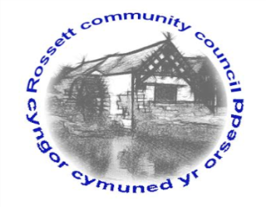

Rossett Community Council

10th February 2022

The next meeting of Rossett Community Council is to be held at Rossett Village Hall on Wednesday 16th February 2022 at 7.30pm to transact the following business.

Wendy Pace
Clerk for the Council
AGENDA

Declarations of Interest
Members are reminded that they should declare the existence and nature of any personal or prejudicial interest in the business of this meeting.

- Apologies for absence

- Approval of the Minutes of the 19th January 2022 meeting

- Crime Report

- Representation's from General Public
Mr Rowlands – Spar shop, Station Road

- Matters Arising
- Hwb Yr Orsedd
- Traffic Order – The Green

- Matters to be discussed:
- Station Road car park – Cllr Parrington
- Queens Jubilee Event/Garden – Cllr Parrington
- Speeding/Lighting Trevalyn – Cllr Woods
- Community Speed Watch – Cllr Jones

7. Reports: To receive updates from the following:
- County Councillor Jones’ Report
- Clerk’s Report
- Reports from Community Councillors
- Youth Representative

8. Finance:
- Finance Report
- Invoices payable (see attached schedule)

9. Planning:

P/2022/0063 – 1 Alyn Drive, Rossett – Variation of Condition 3 of Planning Permission P/2021/0949 to Amend Approved Plans, comments requested by 10/02/22.

P/2022/0085 – Pentlands, The Green, Rossett – First Floor Side Extension.

P/2022/0075 – Lilac Cottage, Stringers Lane, Burton, Rossett – Two Storey Front and Side Extensions.

P/2022/1022 – Three Acres, Rosemary Lane, Burton, Rossett – Variation of Condition 2 of Planning Permission P/2021/0153 to Amend Approved Plans.

10. Other Items brought to the Council’s Attention by Councillors

11. Date, Venue and Time of next meeting: Wednesday 16th March 2022 at 7.30pm at Rossett Village Hall.
_____________________________________________________________
Clerk : Wendy Pace : clerk@rossettcommunitycouncil.cymru Tel: 07421 261118

If you would like to view this meeting on Zoom, please email the Clerk to request the meeting ID.

