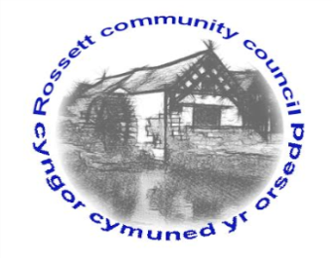

Rossett Community Council

10th March 2022

The next meeting of Rossett Community Council is to be held at Rossett Village Hall on Wednesday 16th March 2022 at 7.30pm to transact the following business.

Wendy Pace
Clerk for the Council
AGENDA

Declarations of Interest
Members are reminded that they should declare the existence and nature of any personal or prejudicial interest in the business of this meeting.

- Apologies for absence

- Approval of the Minutes of the 16th February 2022 meeting

- Crime Report

- Representation's from General Public

- Matters Arising
- Hwb Yr Orsedd
- Traffic Order – The Green

- Matters to be discussed:
- Village Hall Festival – Zia/Cllr Parrington
- One Voice Wales Membership – Clerk
- Scarecrow Festival

7. Reports: To receive updates from the following:
- County Councillor Jones’ Report
- Clerk’s Report
- Reports from Community Councillors
- Youth Representative

8. Finance:
- Finance Report
- Invoices payable (see attached schedule)
- NJC Pay Award
- Audit 2021-22

9. Planning:

P/2022/0147 – 11 Alyn Drive, Rossett – Erections of Porch and Two Storey Rear Extension, comments requested by 04/03/22.

P/2022/0147 – 4 Moss Green, Rossett – Single Storey Side Extension and New Roof on Rear Extension, comments requested by 04/03/22.

Draft Application – Ballswood Quarry, Gegin Lane, Llay - 2 proposed extensions to the extraction boundary.

P/2022/0231 – Land at Mill Brook Close, Lavister – Outline Application (All Matters Reserved) For Up to 7 Dwellings.

P/2022/0246 – Sandford Barn, Trevalyn Farm, Darland Lane, Rossett – Alterations to House and Garage, Single Storey Rear Extension, Front Entrance Canopy and Single Storey Outbuilding.

10. Other Items brought to the Council’s Attention by Councillors

11. Date, Venue and Time of next meeting: Wednesday 21st April 2022 at 7.30pm at Rossett Village Hall.
_____________________________________________________________
Clerk : Wendy Pace : clerk@rossettcommunitycouncil.cymru Tel: 07421 261118

If you would like to view this meeting on Zoom, please email the Clerk to request the meeting ID.

