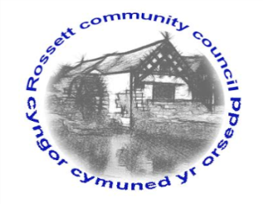

Rossett Community Council

14th March 2022

The next meeting of Rossett Community Council is to be held at Rossett Village Hall on Wednesday 20th April 2022 at 7.30pm to transact the following business.

Wendy Pace
Clerk for the Council

AGENDA

Declarations of Interest
Members are reminded that they should declare the existence and nature of any personal or prejudicial interest in the business of this meeting.

- Apologies for absence

- Approval of the Minutes of the 16th March 2022 meeting

- Crime Report

- Representation's from General Public

- Matters Arising
- Hwb Yr Orsedd
- Traffic Order – The Green
- Community Speed Watch - Clerk

- Matters to be discussed:
- Village Hall Festival – Zia/Cllr Parrington
- Jubilee Garden/Planting – Cllr Parrington

7. Reports: To receive updates from the following:
- County Councillor Jones’ Report
- Clerk’s Report
- Reports from Community Councillors
- Youth Representative

8. Finance:
- Finance Report
- Invoices payable (see attached schedule)
- Three Year Financial Plan

9. Planning:

P/2022/0261 – 23 West Way, Rossett – Erection of Porch, comments requested by 08/04/22.

P/2022/0273 – Land at Johns Court, Burton, Rossett – Creation of Off Road Parking Area, comments requested by 08/04/22.

P/2022/0298 – Sandford Barn, Trevalyn Farm, Darland Lane, Rossett – Listed Building Consent for Alterations to House and Garage, Single Rear Extension, Front Entrance Canopy and Single Storey Outbuilding.

P/2022/0308 – Mount Alyn Croft, Croeshowell Hill, Burton, Rossett – Single Storey Rear Extension and Erection of Outbuilding.

P/2022/0312 – Orchard House, Trevalyn Manor, Manor Lane, Rossett – Listed Building Consent for Installation of Electric Vehicle Charging Point (In Retrospect).

P/2022/0314 – 59 Harwoods Lane, Rossett – Erection of Garage.

P/2022/0318 – 12 West Way, Rossett – Single Storey Front Extension.

10. Other Items brought to the Council’s Attention by Councillors

11. Date, Venue and Time of next meeting: Wednesday 18th May 2022 at 7.30pm at Rossett Village Hall.
_____________________________________________________________
Clerk : Wendy Pace : clerk@rossettcommunitycouncil.cymru Tel: 07421 261118

If you would like to view this meeting on Zoom, please email the Clerk to request the meeting ID.

