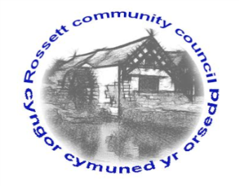

Rossett Community Council

11th May 2022

The next meeting of Rossett Community Council is to be held at Rossett Village Hall on Wednesday 18th May 2022 at 7.30pm to transact the following business.

Joni Rusling
Clerk for the Council

AGENDA

Declarations of Interest
Members are reminded that they should declare the existence and nature of any personal or prejudicial interest in the business of this meeting.

- Apologies for absence

- Approval of the Minutes of the 20th April 2022 meeting

- Crime Report

- Appointment of Officers
(i) Chair
(ii) Vice Chair
(iii) Floods Partnership
(iv) Recreation Grounds Committee
(v) Finance Committee
(vi) Staffing Committee
(vii) Planning Committee
(viii) Wrexham Town & Communities Forum
(ix) One Voice Wales Representative
(x) St Peters School Governor

- Representation's from General Public

- Matters Arising
- Hwb Yr Orsedd
- Traffic Order – The Green
- Community Speed Watch - Clerk

- Matters to be discussed:
- Community Council Vacancies/Thanks to previous Councillors-Cllr Parrington

7. Reports: To receive updates from the following:
- County Councillor Jones’ Report
- Clerk’s Report
- Reports from Community Councillors
- Youth Representative

8. Finance:
- Finance Report
- Invoices payable (see attached schedule)
- Internal Audit 2021/22 - Annual Governance Statement

9. Planning:

P/2022/0382 - 14 Trevalyn Way – Insertion of window in side elevation (in retrospect), comments requested by 12/05/22.

P/2022/0415 – 1 Rossett Road Cottages – Two storey side and rear extension.

P/2022/0231 – Outline Application (All Matters Reserved) for up to 7 dwellings land at Mill Brook Close, Lavister.

P/2022/0298 - Sandford Barn, Darland Lane, Rossett (Revised Plans) - The Conservation Officer is now happy with these proposals. The canopy to the front door has been removed and the windows to the rear extension have been altered. Please note that the proposal now includes a small garden room within the residential curtilage.

10. Other Items brought to the Council’s Attention by Councillors

11. Date, Venue and Time of next meeting: Wednesday 15th June 2022 at 7.30pm at Rossett Village Hall.
_____________________________________________________________
Clerk : Joni Rusling : clerk@rossettcommunitycouncil.cymru Tel: 07421 261118

If you would like to view this meeting on Zoom, please email the Clerk to request the meeting ID.

