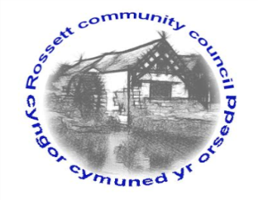

Rossett Community Council

6th June 2022

The next meeting of Rossett Community Council is to be held at Rossett Village Hall on Wednesday 15th June 2022 at 7.30pm to transact the following business.

Joni Rusling
Clerk for the Council

AGENDA

Declarations of Interest
Members are reminded that they should declare the existence and nature of any personal or prejudicial interest in the business of this meeting.

- Apologies for absence

- Approval of the Minutes of the 18th May 2022 meeting

- Crime Report

- Representation's from General Public

- Matters Arising
- Hwb Yr Orsedd
- Traffic Order – The Green
- Community Speed Watch - Clerk

- Matters to be discussed:
- Co-option candidates

7. Reports: To receive updates from the following:
- County Councillor Jones’ Report
- Clerk’s Report
- Reports from Community Councillors
- Youth Representative

8. Finance:
- Finance Report
- Invoices payable (see attached schedule)
- Internal Audit 2021/22 - Annual Governance Statement

9. Planning:

P/2022/0492 - Works to trees in rossett conservation area - Holmleigh Station road Rossett

P/2022/0493 – 9 Broadoaks Rossett - single storey rear extension

P/2022/0487 – 21 Darland lane Rossett wrexham - single storey side extension

P/2022 /0521 - land north of the elms Darland lane Rossett outline application for erection of 3 dwellings (all matters reserved)

P/2022 /0525 - Barton house Darland lane Rossett conversion of building to 3 dwellings

P/2022 /0533 - Brook House Chester road Lavister Works to trees protected by tree preservation order wcbc 179

10. Other Items brought to the Council’s Attention by Councillors

11. Date, Venue and Time of next meeting: Wednesday 20th July 2022 at 7.30pm at Rossett Village Hall.
_____________________________________________________________
Clerk : Joni Rusling : clerk@rossettcommunitycouncil.cymru Tel: 07421 261118

If you would like to view this meeting on Zoom, please email the Clerk to request the meeting ID.

