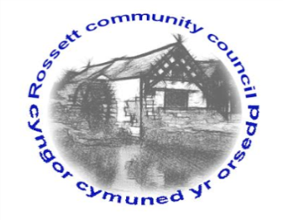

Rossett Community Council

13th July 2022

The next meeting of Rossett Community Council is to be held at Rossett Village Hall on Wednesday 20th July 2022 at 7.30pm to transact the following business.

Joni Rusling
Clerk for the Council

AGENDA

Declarations of Interest
Members are reminded that they should declare the existence and nature of any personal or prejudicial interest in the business of this meeting.

23. Apologies for absence

24. Approval of the Minutes of the 15th June 2022 meeting

25. Crime Report

26. Representation's from General Public
- Pedestrian Railway Crossing between Burton and Station Road – G. Smith

27. Matters Arising
- Hwb Yr Orsedd – Report from C. Guest
- Traffic Order – The Green
- Community Speed Watch – Clerk

28. Matters to be discussed:
(i) Lavister Barrels Stolen/Replacement action – Cllr Parrington

29. Reports: To receive updates from the following:
- County Councillor Jones’ Report
- Clerk’s Report
- Reports from Community Councillors
- Youth Representative
- One Voice Wales Meeting Update – Cllr H Maurice-Jones

30. Finance:
- Finance Report
- Invoices payable (see attached schedule)
- Internal Audit 2021/22 - Annual Governance Statement

31. Planning:

P/ 2022/ 0547 Proposed works to tree in conservation area – Christ Church and Church Hall Chester Road (comments were due by 12.7.22)

32. Other Items brought to the Council’s Attention by Councillors

33. Date, Venue and Time of next meeting: Wednesday 17th August 2022 at 7.30pm at Rossett Village Hall.
_____________________________________________________________
Clerk : Joni Rusling : clerk@rossettcommunitycouncil.cymru Tel: 07421 261118

If you would like to view this meeting on Zoom, please email the Clerk to request the meeting ID.

