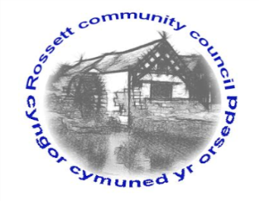

Rossett Community Council

12th August 2022

The next meeting of Rossett Community Council is to be held at Rossett Village Hall on Wednesday 17th August 2022 at 7.30pm to transact the following business.

Joni Rusling
Clerk for the Council

AGENDA

Declarations of Interest
Members are reminded that they should declare the existence and nature of any personal or prejudicial interest in the business of this meeting.

1. Apologies for absence

2. Approval of the Minutes of the 20th July 2022 meeting

3. Crime Report

4. Representation's from General Public

5. Matters Arising
- Hwb Yr Orsedd
- Traffic Order – The Green
- Community Speed Watch – Clerk
- Lavister Barrels Stolen/Replacement action – Cllr Parrington
- Lavister Boundry sign – Cllr Gledhill/Clerk
- Gun Street Fence – Youth Rep J Steven/Cllr Steven

6. Matters to be discussed:
- Tree Inspections – Cllr P. Roberts
- Land Development by Lavister Vets – Cllr Parrington
- The Broadoak footpath (Brambles/crops) – Cllr Steven

7. Reports: To receive updates from the following:
- County Councillor Jones’ Report
- County Councillor Shepherd’s Report
- Clerk’s Report
- Reports from Community Councillors
- Parks Committee
- Youth Representative

8. Finance:
- Finance Report
- Invoices payable (see attached schedule)

9. Planning:

P/ 2022/0636 - Oakmead Golly Rossett Wrexham - Change of use of land to tourist accommodation and erection of two glamping pods – comments were due by 11th August and there were no objections

P/2022 /0642 - 9 The Copse Rossett Wrexham - works to trees protected by tree preservation order wcbc 10 - comments due by 15th August

P/2022/0657 - 1 Croeshowell Court Croeshowell Hill Burton Rossett -
Single storey rear extension

P/2022 /0680 - 97 Harwoods Lane Rossett - Single storey rear extension

10. Other Items brought to the Council’s Attention by Councillors

11. Date, Venue and Time of next meeting: Wednesday 21st September 2022 at 7.30pm at Rossett Village Hall.
_____________________________________________________________
Clerk : Joni Rusling : clerk@rossettcommunitycouncil.cymru Tel: 07421 261118

If you would like to view this meeting on Zoom, please email the Clerk to request the meeting ID.

