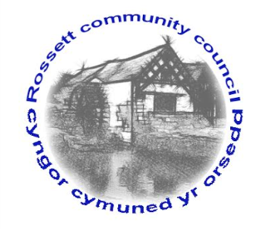

Rossett Community Council

12th January 2017

The next meeting of Rossett Community Council is to be held at Rossett Presbyterian Church, Station Road, Rossett on Wednesday 18th January 2017 at 7.30pm to transact the following business.

Yours faithfully

Sarah Tushingham

Clerk for the Council

AGENDA

Declarations of Interest
Members are reminded that they should declare the existence and nature of any personal or prejudicial interest in the business of this meeting.

- Apologies for absence.

- Approval of the Minutes of the 21st December 2016 meeting.

- (i) Police Report;
(ii) Review of policing priorities;
(iii) Community Speed Watch Team.

- Matters arising:

- Update on changes to the banking system and Financial Regulations;

- Update on Health & Safety Policy and Risk Assessment
Policy of all recreation grounds (Cllr. Dolan).

- Matters to be discussed:

- Gresford allotments;
- School crossing patrol;
- Campaign to end loneliness (Cllr. Pretsell);
- Review of Standing Orders and Financial Regulations;
- Community Inclusion Grant.

6. Reports : To receive updates from the following:

- County Councillor Jones’ Report
- Clerk’s Report (copy attached)
- Parks and Recreation sub-committee Report
- Reports from Community Councillors

- Planning :

P/2016/1170 – Erection of steel framed lean-to : Balls Hall Farm, Burton
P216/1169 – Erection of Portal steel framed side extension : Balls Hall Farm, Burton

8. Finance:

- Financial position December 2016;
- Invoices payable (see attached schedule);
- Discussion on amendment to the 2017 Precept figure;
- Interim Audit Report.

9. Any other business.

10. Date, Venue and Time of next meeting : Wednesday [ ] February 2017 at 7.30pm at the Presbyterian Church, Station Road, Rossett.
_____________________________________________________________

Clerk : Sarah Tushingham : clerk@rossettcommunitycouncil.cymru

