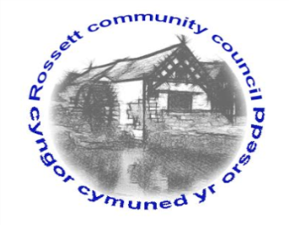

Rossett Community Council

12th January 2023

The next meeting of Rossett Community Council is to be held at the Presbyterian Church Village Hall on Wednesday 18th January at 7.30pm to transact the following business.

Joni Rusling
Clerk for the Council

AGENDA

Declarations of Interest
Members are reminded that they should declare the existence and nature of any personal or prejudicial interest in the business of this meeting.

1. Apologies for absence

2. Approval of the Minutes of the 21st December meeting

3. Crime Report

4. Representation's from General Public

5. Matters Arising
- Hwb Yr Orsedd
- Traffic Order – The Green
- Community Speed Watch
- Mountain View Grounds

6. Matters to be discussed:
- Gambling License – Clerk
- WCBC play area SLA – Clerk
- Staff Overtime and Safety – Cllr Parrington/Clerk

7. Reports: To receive updates from the following:
- County Councillors Reports –Cllr Jones & Cllr Shepherd
- Clerk’s Report
- Reports from Community Councillors
- Parks Committee
- Events Committee
- Staffing Committee
- Floods Committee
- Youth Representative

8. Finance:
- Finance Report
- Invoices payable (see attached schedule)

9. Planning:

P/2022/1032 - The Pharmacy Chester Road Rossett - First Floor Extension And Change Of Use Of Part Of Ground Floor To Additional Pharmacy Storage

10. Other Items brought to the Council’s Attention by Councillors

11. Date, Venue and Time of next meeting: Wednesday 15th February 2023 at 7.30pm at Presbyterian Church Village Hall.
_____________________________________________________________
Clerk : Joni Rusling : clerk@rossettcommunitycouncil.cymru Tel: 07421 261118

