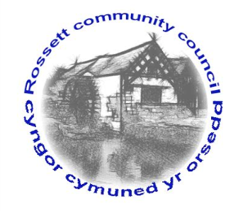

Rossett Community Council

9th February 2017

The next meeting of Rossett Community Council is to be held at Rossett Presbyterian Church, Station Road, Rossett on Wednesday 15th February 2017 at 7.30pm to transact the following business.

Yours faithfully

Sarah Tushingham

Clerk for the Council

AGENDA

Declarations of Interest
Members are reminded that they should declare the existence and nature of any personal or prejudicial interest in the business of this meeting.

- Apologies for absence.

- Approval of the Minutes of the 18th January 2017 meeting.

- J10 Planning Ltd representative : Re Proposed development on Rossett Road / Holt Road.

- Police Report.

- Matters arising:

- Update on changes to the banking system (Clerk);

- Update on Health & Safety Policy and Risk Assessment
Policy of all recreation grounds (Cllr. Dolan);

- Update on school crossing;

- Update on End Loneliness Campaign (Grants) (Cllr. Pretsell);

- Matters to be discussed:

- Adoption of amended Standing Orders and Financial Regulations;
- Speeding;
- Review of actions from previous Minutes;
- Post Office update;
- Elections;
- Service Level Agreement for parks.

7. Reports : To receive updates from the following:

- County Councillor Jones’ Report
- Clerk’s Report (copy attached)
- Parks and Recreation sub-committee Report
- Reports from Community Councillors

- Planning :

P/2017/0031 : The Cottage, Darland Hall, Darland Lane, Rossett
P/2017/0057 : Tregarthen, Chester Road, Rossett
P/2017/0072 : Lower Honkley Farm, Stringers Lane, Burton
P/2017/0077 : Innisfree, Croeshowell Lane, Burton

9. Finance:

- Financial position January 2016;
- Invoices payable (see attached schedule);

10. Any other business.

11. Date, Venue and Time of next meeting : Wednesday 15th March 2017 at 7.30pm at the Presbyterian Church, Station Road, Rossett.
_____________________________________________________________

Clerk : Sarah Tushingham : clerk@rossettcommunitycouncil.cymru

