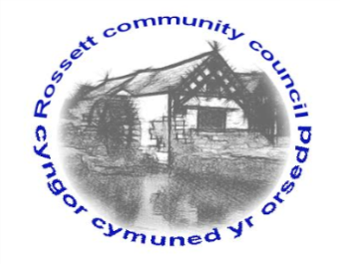

Rossett Community Council

15th February 2024

The next meeting of Rossett Community Council is to be held at the Presbyterian Church Village Hall on Wednesday 21st February at 7.30pm to transact the following business.

Joni Rusling
Clerk for the Council

AGENDA

Declarations of Interest
Members are reminded that they should declare the existence and nature of any personal or prejudicial interest in the business of this meeting.

1. Apologies for absence

2. Approval of the Minutes of the 17th January meeting

3. Crime Report

4. Representation's from General Public

5. Matters Arising
- Hwb Yr Orsedd
- Traffic Order – The Green
- Community Speed Watch
- Allotments – Cllr W Cleaver
- Underpass Antisocial Behaviour
6. Matters to be discussed:
- Litter Picking group – Community Agent
- Rossett Park Grant for Toddler Play area – Clerk/Parks Committee
- Councillor Vacancy - Clerk

7. Reports: To receive updates from the following:
- County Councillors Reports –Cllr Jones & Cllr Shepherd
- Clerk’s Report
- Reports from Community Councillors
- Parks Committee
- Events Committee
- Staffing Committee
- Floods Committee
- Youth Representative

8. Finance:
- Finance Report
- Invoices payable (see attached schedule)

9. Planning:

P/2023/0231 - Section 78 Appeal at: Lower Rackery House, Dark Lane, Burton

P/2024/0043 - Rossett Park The Green Rossett - Installation Of Solar Panels And Air Source Heat Pump Within A Conservation Area

P/2024/0042 - 1 Lower Parkside Cottages Parkside Rossett - Erection Of Single Storey Garage

P/2024/0044 - Yew Tree Farm Llay Road Rossett - Erection Of Agricultural Building For Storage Of Straw And Machinery And All Associated Works

10. Other Items brought to the Council’s Attention by Councillors

11. Date, Venue and Time of next meeting: Wednesday 20th March 2024 at 7.30pm at Presbyterian Church Village Hall.
_____________________________________________________________
Clerk : Joni Rusling : clerk@rossettcommunitycouncil.cymru Tel: 07421 261118

