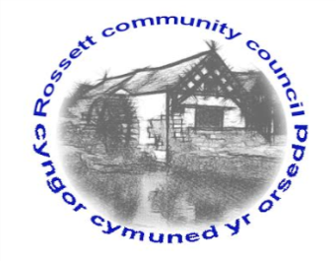

Rossett Community Council

15th March 2024

The next meeting of Rossett Community Council is to be held at the Presbyterian Church Village Hall on Wednesday 20th March at 7.30pm to transact the following business.

Joni Rusling
Clerk for the Council

AGENDA

Declarations of Interest
Members are reminded that they should declare the existence and nature of any personal or prejudicial interest in the business of this meeting.

1. Apologies for absence

2. Approval of the Minutes of the 21st February meeting

3. Crime Report

4. Representation's from General Public

5. Matters Arising
- Allotments – Cllr W Cleaver
- Underpass Antisocial Behaviour
- Councillor Vacancy – Clerk
6. Matters to be discussed:
- Footpaths – Cllr H Maurice-Jones
- Recycle Bins – Cllr W Cleaver

7. Reports: To receive updates from the following:
- County Councillors Reports –Cllr Jones & Cllr Shepherd
- Clerk’s Report
- Reports from Community Councillors
- Parks Committee (incl. Grant update)
- Events Committee
- Staffing Committee (Park Warden Holidays)
- Floods Committee
- One Voice Wales
- St Peters School
- Youth Representative

8. Finance:
- Finance Report
- Invoices payable (see attached schedule)

9. Planning:

P/2023/0036 - Section 78 Appeal at: , Gamford House, Gamford Lane, Rossett

P/2024/0092 - Land Adjacent To Mount Alyn Gatehouse Croeshowell Hill Rossett - Application For Erection Of 5 Dwellings And Proposed New
Access (Appearance And Landscaping Reserved) Comments due day of meeting

P/2024/0133 - 22 Trevalyn Way, Rossett - Conversion Of Car Port Into Habitable Room, First Floor Extension Above Garage/Existing Carport And Installation Of New First Floor Window To Existing Gable Wall

10. Other Items brought to the Council’s Attention by Councillors

11. Date, Venue and Time of next meeting: Wednesday 17th April 2024 at 7.30pm at Presbyterian Church Village Hall.
_____________________________________________________________
Clerk : Joni Rusling : clerk@rossettcommunitycouncil.cymru Tel: 07421 261118

