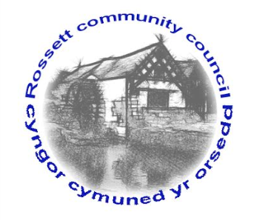

Rossett Community Council

9th March 2017

The next meeting of Rossett Community Council is to be held at Rossett Presbyterian Church, Station Road, Rossett on Wednesday 15th March 2017 at 7.30pm to transact the following business.

Yours faithfully

Sarah Tushingham

Clerk for the Council

AGENDA

Declarations of Interest
Members are reminded that they should declare the existence and nature of any personal or prejudicial interest in the business of this meeting.

- Apologies for absence.

- Approval of the Minutes of the 15th February 2017 meeting.

- Mr Nigel Davies to discuss the Community Agent Initiative.

- Co-op Store Manager to discuss any matters arising with regard to the new store.

- Police Report.

- Matters arising:

- School crossing (Clerk);
- Toilet block update (Cllr. Guest);
- Darland survey re the park (Cllr. Pretsell);
- River wall, Burton (Cllr. Smith)

- Matters to be discussed:

- Elections (Clerk);
- Street lighting (Cllr. Morris);
- Co-op community donation (Clerk);
- Village Festival 2017 (Clerk);
- Wrexham Play Sufficiency Grants Programme (Parks Committee);
- Independent Remuneration Panel for Wales (Cllr. Guest);
- Feedback from One Voices Wales meeting (Cllr. Guest)
- Speeding issues in Harwood Lane;
- PCSO Workshop.

7. Reports : To receive updates from the following:

- County Councillor Jones’ Report
- Clerk’s Report
- Parks and Recreation sub-committee Report
- Reports from Community Councillors

- Planning : No new Planning Applications received.

9. Finance:

- Financial position as at 31st January 2017
- Finance Report
- Invoices payable (see attached schedule)

10. Any other business.

11. Date, Venue and Time of next meeting : Wednesday 19th April 2017 at 7.30pm at the Presbyterian Church, Station Road, Rossett.
_____________________________________________________________

Clerk : Sarah Tushingham : clerk@rossettcommunitycouncil.cymru

