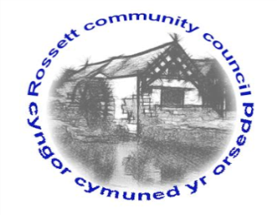

Rossett Community Council

12th April 2024

The next meeting of Rossett Community Council is to be held at the Presbyterian Church Village Hall on Wednesday 17th April at 7.30pm to transact the following business.

Joni Rusling
Clerk for the Council

AGENDA

Declarations of Interest
Members are reminded that they should declare the existence and nature of any personal or prejudicial interest in the business of this meeting.

1. Apologies for absence

2. Approval of the Minutes of the 20th March meeting

3. Crime Report

4. Representation's from General Public
- Councillor Vacancy Applicants – C Morgan & R Tomlinson
- St Peter’s School - S Hatton-Jones

5. Matters Arising
- Allotments – Cllr W Cleaver
- Underpass additional cameras - Clerk
- Footpaths – Cllr H Maurice-Jones
6. Matters to be discussed:
- Gresford United Charities Trustee – Cllr M Woods/Clerk
- One-way System – Cllr A Steven

7. Reports: To receive updates from the following:
- County Councillors Reports –Cllr Jones & Cllr Shepherd
- Clerk’s Report
- Reports from Community Councillors
- Parks Committee
- Events Committee
- Staffing Committee
- Floods Committee
- Youth Representative

8. Finance:
- Finance Report
- Invoices payable (see attached schedule)

9. Planning:

P/ 2024/0190 - Broad Oak Farm Llyndir Lane Burton - Planning Permission P/2018/0888 To Extend Time Limit For Comencement Of Development

P/2023/0260 - Tyn Y Coed Chester Road Rossett - Demolition Of The Existing Dwellings, Erection Of Up To 10 Dwellings And Formation Of New Vehicular Access – AMENDED DESCRIPTION

P/2023/0396 - Pines Burton Road Burton - Erection Of Two Storey Side And Front Extension And Single Storey Rear Extension – TO BE RECONSIDERED

P/2024/0209 - 42 Trevalyn Way Rossett - Conversion Of Existing Garage And Erection Of Detached Garage

10. Other Items brought to the Council’s Attention by Councillors

11. Date, Venue and Time of next meeting: Wednesday 15th May 2024 at 7.30pm at Presbyterian Church Village Hall.
_____________________________________________________________
Clerk : Joni Rusling : clerk@rossettcommunitycouncil.cymru Tel: 07421 261118

