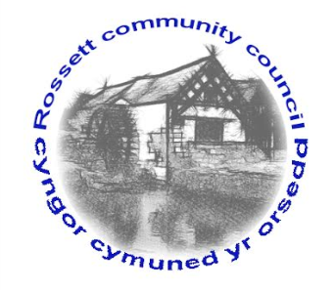

Rossett Community Council

13th April 2017

The next meeting of Rossett Community Council is to be held at Rossett Presbyterian Church, Station Road, Rossett on Wednesday 19th April 2017 at 7.30pm to transact the following business.

Yours faithfully

Sarah Tushingham

Clerk for the Council

AGENDA

Declarations of Interest
Members are reminded that they should declare the existence and nature of any personal or prejudicial interest in the business of this meeting.

- Apologies for absence.

- Approval of the Minutes of the 15th March 2017 meeting.

- Police Report.

- Matters arising:

- Community Agent Scheme;
- School crossing;
- Street lighting – Harwoods Lane (Cllr. Fortune).

- Matters to be discussed:

- Street lighting – Chapel Lane (Clerk);
- Gresford Community Council meeting re Youth Provision (Cllr. Pretsell);
- Appointment of new Clerk.

7. Reports : To receive updates from the following:

- County Councillor Jones’ Report
- Clerk’s Report
- Reports from Community Councillors

- Planning :

P/2016/1157 – Installation of ATM, bollard, plant yard and plant equipment : Butchers Arms

P/2017/0267 – Removal of holly and leylandi hedge and replace with wooden fence – Bywell, Chester Road, Rossett

P/2017 /0307 – Extension : 45 Darland Lane

9. Finance:

- Financial position as at 31st March 2017
- Finance Report
- Invoices payable (see attached schedule)

10. Any other business.

11. Date, Venue and Time of next meeting : Wednesday 18th May 2017 at 7.30pm at the Presbyterian Church, Station Road, Rossett.
_____________________________________________________________

Clerk : Sarah Tushingham : clerk@rossettcommunitycouncil.cymru

