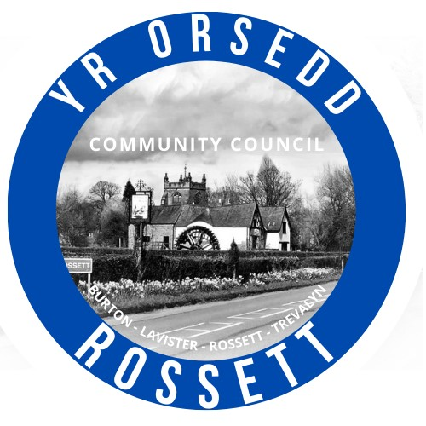
Rossett Community Council

11th February 2025

The next meeting of Rossett Community Council is to be held at the Community Hwb (Hwb Yr Orsedd) on Wednesday 19th February at 7.30pm to transact the following business.

Joni Rusling
Clerk for the Council

AGENDA

Declarations of Interest
Members are reminded that they should declare the existence and nature of any personal or prejudicial interest in the business of this meeting.

1. Apologies for absence

2. Approval of previous minutes

3. Crime Report

4. Representation's from Public

5. Matters Arising

- Allotments – Cllr W Cleaver
- Community Agent

6. Matters to be discussed:
- One Voice Wales AGM – Clerk/Cllr H Maurice-Jones
- Service Level Agreement for Parks Inspections – Clerk

7. Reports: To receive updates from the following:
- Ward County Councillors Reports – Cllr Jones & Cllr Shepherd
- Clerk’s Report
- Reports from Community Councillors
- Parks Committee
- Events Committee
- Staffing Committee
- Floods Committee
- IT/Newsletter Committee
- Youth Representatives

8. Finance:

- Finance Report
- Invoices payable (see attached schedule)

9. Planning:

P/2025/0017 - 1 Park View, Chester Road, Rossett - Change Of Use Of Outbuilding From Hobby Workshop To Aesthetic Clinical Use – comments due 7th Feb

P/2025/0020 - 5 Harwoods Close, Rossett - Installation Of Air Source Heat Pump – comments due 7th Feb

P/2025/0023 - Manderville And Shandon, Llyndir Lane, Burton, Rossett - Removal Of Condition 2 Of Planning Permission Bur/5716 – comments due 13th Feb

P/2025/0071 - Honkley Farm, Stringers Lane, Burton - Two Storey Side Extension And Single Storey Rear Extension

P/2025/0092 - Gabriel House, Darland Lane, Rossett - Single Storey Side Extensions And Alteration To Side Windows

10. Other Items brought to the Council’s Attention by Councillors

11. Date, Venue and Time of next meeting: Wednesday 19th March 2025 at 7.30pm at the Community Hwb.
_________________________________

Clerk : Joni Rusling
clerk@rossettcommunitycouncil.cymru
Tel: 07421261118

