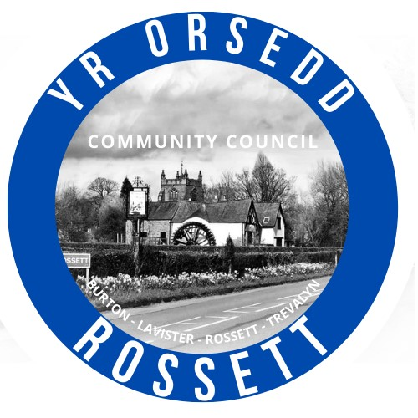
Rossett Community Council

9th April 2025

The next meeting of Rossett Community Council is to be held at the Community Hwb (Hwb Yr Orsedd) on Wednesday 16th April at 7.30pm to transact the following business.

Joni Rusling
Clerk for the Council

AGENDA

Declarations of Interest
Members are reminded that they should declare the existence and nature of any personal or prejudicial interest in the business of this meeting.

1. Apologies for absence

2. Approval of previous minutes

3. Crime Report

4. Representation's from Public

5. Matters Arising

- Allotments – Cllr W Cleaver
- Eisteddfod
6. Matters to be discussed:
- Footpaths

7. Reports: To receive updates from the following:
- Ward County Councillors Reports – Cllr Jones & Cllr Shepherd
- Clerk’s Report
- Reports from Community Councillors
- Parks Committee
- Events Committee
- Staffing Committee
- Floods Committee
- IT/Newsletter Committee
- Community Agent
- Youth Representatives

8. Finance:
- Finance Report
- Invoices payable (see attached schedule)
- Audit 2022-23 & 2023-24
- Audit 2024-25

9. Planning:

P/2025/0259 - 46 Trevalyn Way, Rossett - First Floor Front Extension And Erection Of Porch – Comments Due 10th April

10. Other Items brought to the Council’s Attention by Councillors

11. Date, Venue and Time of next meeting: Wednesday 21st May 2025 at 7.30pm at the Community Hwb.
_________________________________

Clerk : Joni Rusling
clerk@rossettcommunitycouncil.cymru
Tel: 07421261118

