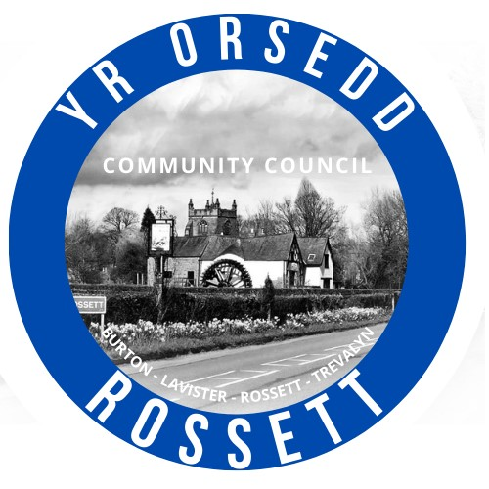
Rossett Community Council
15th May 2025

The next meeting of Rossett Community Council is to be held at the Community Hwb (Hwb Yr Orsedd) on Wednesday 21st May at 7.30pm to transact the following business.

Joni Rusling
Clerk for the Council

AGENDA

Declarations of Interest
Members are reminded that they should declare the existence and nature of any personal or prejudicial interest in the business of this meeting.

1. Apologies for absence

2. Approval of previous minutes

3. Appointment of Officers

(i) Chair
(ii) Vice Chair
(iii) Environmental Committee
(iv) Parks Committee
(v) Finance Committee
(vi) Staffing Committee
(vii) Events Committee
(viii) Wrexham T&C Forum
(ix) One Voice Wales Rep
(x) St Peters School Governor
(xi) GDPR/IT

4. Crime Report

5. Representation's from Public

6. Matters Arising
- Allotments – Cllr W Cleaver
- Eisteddfod
- Footpaths
7. Matters to be discussed:

8. Reports: To receive updates from the following:
- Ward County Councillors Reports – Cllr Jones & Cllr Shepherd
- Clerk’s Report
- Reports from Community Councillors
- Parks Committee
- Events Committee
- Staffing Committee
- Floods Committee
- IT/Newsletter Committee
- Community Agent
- Youth Representatives

9. Finance:
- Finance Report
- Invoices payable (see attached schedule)
- Internal Audit 2024-25

10. Planning:

P/2025/0373 - Carisbrooke, Croeshowell Lane, Burton - Installation Of Air Source Heat Pump

P/2025/0374 - Raven Oak, The Green, Rossett - Single Storey Rear Extension

11. Other Items brought to the Council’s Attention by Councillors

12. Date, Venue and Time of next meeting: Wednesday 18th June 2025 at 7.30pm at the Community Hwb.
_________________________________

Clerk : Joni Rusling clerk@rossettcommunitycouncil.cymru
Tel: 07421261118

