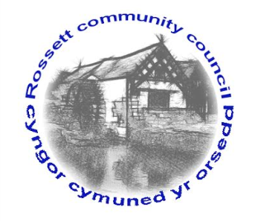

Rossett Community Council

9th May 2017

The next meeting of Rossett Community Council is to be held at Rossett Presbyterian Church, Station Road, Rossett on Wednesday 17th May 2017 at 7.30pm to transact the following business.

Yours faithfully

Wendy Pace

Clerk for the Council

AGENDA

Declarations of Interest
Members are reminded that they should declare the existence and nature of any personal or prejudicial interest in the business of this meeting.

- Apologies for absence.

- Approval of the Minutes of the 19th April 2017 meeting.

- Police Report.

- Appointment of Officers
(i) Chair
(ii) Vice Chair
(iii) Floods Partnership
(iv) Recreation Grounds Committee
(v) Finance Committee
(vi) Fetes & Festivals Committee
(vii) Wrexham Town & Communities Forum
(viii) One Voice Wales Representative
(ix) St Peters School Governor

5. Co-option of Councillors

6. Matters arising:

- Community Agent Scheme;
- School crossing;
- Street lighting – Harwoods Lane;
- Street lighting - Chapel Lane
- Youth Provision (Cllr Pretsell)
- Play Grant (Clerk)
- Play Equipment Survey (Cllr Pretsell/Cllr Parrington)
- Co-op Community Donation (Cllr Parrington)

7. Matters to be discussed:

- Funding Request - WW1 Monument Bellevue Park (Clerk);
- Post Office Temporary Closure (Clerk);
- Insurance Policy (Clerk).

8. Reports : To receive updates from the following:

- County Councillor Jones’ Report
- Clerk’s Report
- Reports from Community Councillors

9. Planning :

P/2017/0273 – Erection of replacement Oak Framed Garage with room above - Darland Barn, Darland Lane

10. Finance:

- Financial position as at 30th April 2017
- Finance Report
- Invoices payable (see attached schedule)

11. Any other business.

12. Date, Venue and Time of next meeting : Wednesday 21st June 2017 at 7.30pm at the Presbyterian Church, Station Road, Rossett.
_____________________________________________________________

Clerk : Wendy Pace : clerk@rossettcommunitycouncil.cymru

