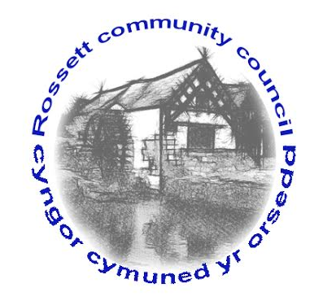

Rossett Community Council

14th May 2017

The next meeting of Rossett Community Council is to be held at Rossett Presbyterian Church, Station Road, Rossett on Wednesday 21st June 2017 at 7.30pm to transact the following business.

Yours faithfully

Wendy Pace
Clerk for the Council

AGENDA

Declarations of Interest
Members are reminded that they should declare the existence and nature of any personal or prejudicial interest in the business of this meeting.

- Apologies for absence.

- Approval of the Minutes of the 17th May 2017 meeting.

- Police Report.

- Mr Peter Agnew/Cllr Robert Walsh regarding Darland school crossing.

- Lisa Jones Co-op Member Pioneer to explain co-op community working in local area.

- Appointment of Officers
(i) One Voice Wales Representative
(ii) St Peters School Governor

5. Matters arising:

- Community Agent Scheme;
- Street lighting - Holt Road
- Play Grant (Clerk)
- Play Equipment Survey (Cllr Pretsell/Cllr Parrington)
- Street lighting - Harwoods Lane

6. Matters to be discussed:

- Relocation of street light - Three Acres;

7. Reports : To receive updates from the following:

- County Councillor Jones’ Report
- Clerk’s Report
- Parks and Recreation sub-committee Report
- Reports from Community Councillors

8. Planning :

Pre-application consultation prior to submission of planning application at Broad Oak Farm - conversion o f barns to form 13 residential units

9. Finance:

- Financial position as at 31st May 2017
- Finance Report
- Invoices payable (see attached schedule)

10. Any other business.

11. Date, Venue and Time of next meeting : Wednesday 19th July 2017 at 7.30pm at the Presbyterian Church, Station Road, Rossett.
_____________________________________________________________
Clerk : Wendy Pace : clerk@rossettcommunitycouncil.cymru

