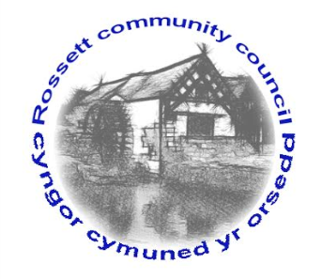

Rossett Community Council

12th July 2017

The next meeting of Rossett Community Council is to be held at Rossett Presbyterian Church, Station Road, Rossett on Wednesday 19th July 2017 at 7.30pm to transact the following business.

Yours faithfully

Wendy Pace
Clerk for the Council

AGENDA

Declarations of Interest
Members are reminded that they should declare the existence and nature of any personal or prejudicial interest in the business of this meeting.

- Apologies for absence.

- Approval of the Minutes of the 21st June 2017 meeting.

- Police Report.

4. Representation's from General Public

5. Matters arising:

- Community Agent Scheme;
- Darland High - School Crossing
- Public meeting - Traffic movement around The Green
- Planter sponsorship

6. Matters to be discussed:

- Cadwyn Clwyd - Steering Group;
- Risk Assessment.

7. Reports : To receive updates from the following:

- County Councillor Jones’ Report
- Clerk’s Report
- Finance Sub Committee
- Reports from Community Councillors

8. Planning :

P/2017/0501 - Land opposite former Golden Groves - Erection of Stable block, tack room, feed store, hay store and construction of menage.

P/2017/0518 - Briarley, Burton Road, Burton - Two-Storey Extension.

P/2017/0522 - 1 Harwoods Lane, Rossett - First floor and Single-storey extension and pitched roof over front porch.

P/2017/0530 - New Farm, Cobblers Lane, Burton - Construction of above ground Steel Slurry Tank.

P/2017/0554 - Burton Hall, Burton Hall Road, Burton - Steel Framed Agricultural Building Extension.

P/2017/0558 - Burton Green Cottage, Burton - Change of Use of Agricultural Land to residential curtilage and erection of timber frame domestic garage (partly in retrospect).

P/2017/0567 - 5 Grosvenor Crescent, Rossett - Garage Extension.

P2016/0712 Section 78 Appeal - Bungalow, Darland Lodge - Notification of Appeal

9. Finance:

- Financial position as at 30th June 2017
- Finance Report - Including Acceptance of Financial Risk Assessment
- Invoices payable (see attached schedule)

10. Any other business.

11. Date, Venue and Time of next meeting : Wednesday 16th August 2017 at 7.30pm at the Presbyterian Church, Station Road, Rossett.
_____________________________________________________________
Clerk : Wendy Pace : clerk@rossettcommunitycouncil.cymru

