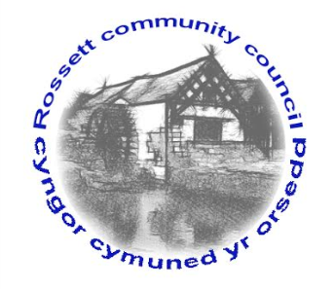

Rossett Community Council

9th August 2017

The next meeting of Rossett Community Council is to be held at Rossett Presbyterian Church, Station Road, Rossett on Wednesday 16th August 2017 at 7.30pm to transact the following business.

Yours faithfully

Wendy Pace
Clerk for the Council

AGENDA

Declarations of Interest
Members are reminded that they should declare the existence and nature of any personal or prejudicial interest in the business of this meeting.

- Apologies for absence.

- Approval of the Minutes of the 19th July 2017 meeting.

- Police Report.

4. Representation's from General Public

5. Matters arising:

- Community Agent
- Darland High - School Crossing
- Public meeting - Traffic movement around The Green
- Cadwyn Clwyd - Steering Group
- Staffing Sub Committee

6. Matters to be discussed:

- Possible change of location for meetings.

7. Reports : To receive updates from the following:

- County Councillor Jones’ Report
- Clerk’s Report
- Parks/Recreational Sub Committee
- Reports from Community Councillors

8. Planning :

P/2017/0623 - Broad Oak Farm, Llyndir Lane, Burton - Change of use and conversion of Barns to 13 residential units.

P/2017/0676 - Three Acres, Rosemary Lane, Burton - Two-Storey and Single-Storey Extensions to dwelling.

9. Finance:

- Financial position as at 30th June 2017
- Finance Report
- Invoices payable (see attached schedule)

10. Any other business.

None Received

11. Date, Venue and Time of next meeting : Wednesday 20th September 2017 at 7.30pm at the Presbyterian Church, Station Road, Rossett.
_____________________________________________________________
Clerk : Wendy Pace : clerk@rossettcommunitycouncil.cymru

