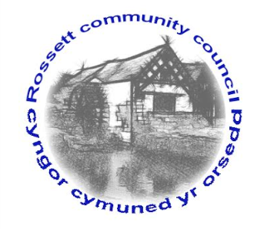

Rossett Community Council

13th September 2017

The next meeting of Rossett Community Council is to be held at Rossett Presbyterian Church, Station Road, Rossett on Wednesday 20th September 2017 at 7.30pm to transact the following business.

Yours faithfully

Wendy Pace
Clerk for the Council

AGENDA

Declarations of Interest
Members are reminded that they should declare the existence and nature of any personal or prejudicial interest in the business of this meeting.

- Apologies for absence.

- Approval of the Minutes of the 16th August 2017 meeting.

- Police Report.

4. Representation's from General Public

5. Matters arising:

- Community Agent
- Cadwyn Clwyd - Steering Group

6. Matters to be discussed:

- Possible change of location for meetings
- Tree Trimming - Cllr Roberts
- Parking on Station Road - Cllr Cleaver
- Flooding in Waverley Crescent - Cllr Cleaver
- Feedback from Village Festival - Cllr Cleaver
- CCTV Burton/Playground - Clerk
- Christmas Tree Light Switch on - Cllr Parrington
7. Reports : To receive updates from the following:

- County Councillor Jones’ Report
- Clerk’s Report
- Finance Sub Committee
- Reports from Community Councillors

8. Planning :

None received

9. Finance:

- Finance Report
- Invoices payable (see attached schedule)
- Budget submissions from sub-committees for next financial year

10. Any other business.

11. Date, Venue and Time of next meeting : Wednesday 18th October 2017 at 7.30pm at the Presbyterian Church, Station Road, Rossett.
_____________________________________________________________
Clerk : Wendy Pace : clerk@rossettcommunitycouncil.cymru

