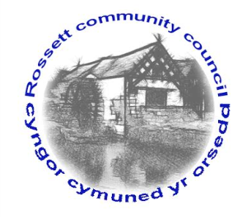

Rossett Community Council

11th October 2017

The next meeting of Rossett Community Council is to be held in the Back Room at Rossett Village Hall, Station Road, Rossett on Wednesday 18th October 2017 at 7.30pm to transact the following business.

Yours faithfully

Wendy Pace
Clerk for the Council

AGENDA

Declarations of Interest
Members are reminded that they should declare the existence and nature of any personal or prejudicial interest in the business of this meeting.

- Apologies for absence.

- Approval of the Minutes of the 20th September 2017 meeting.

- Police Report.

(i) Cuppa with a Copper

4. Representation's from General Public

5. Matters arising:

- Community Agent
- CCTV

6. Matters to be discussed:

(i) Volunteer litter picks - Clerk

7. Reports : To receive updates from the following:

- County Councillor Jones’ Report
- Clerk’s Report
- Finance Sub Committee
- Parks and Recreational grounds Sub Committee
- Staffing Committee
- Reports from Community Councillors

8. Planning:

P/2017/0801 - Y Celyn, Station Road, Rossett - Front Extension to provide New Double Garage with New Bedroom and Shower Room

9. Finance:

- Finance Report
- Invoices payable (see attached schedule)
- Budget submissions from sub-committees for next financial year

10. Any other business

11. Date, Venue and Time of next meeting : Wednesday 15th November 2017 at 7.30pm at the Presbyterian Church, Station Road, Rossett.
_____________________________________________________________
Clerk : Wendy Pace : clerk@rossettcommunitycouncil.cymru

