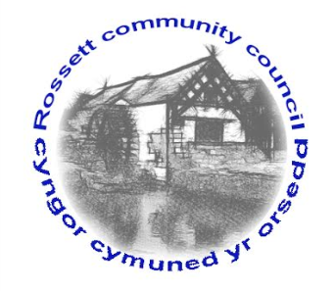

Rossett Community Council

8th November 2017

The next meeting of Rossett Community Council is to be held at Rossett Presbyterian Church, Station Road, Rossett on Wednesday 15th November 2017 at 7.30pm to transact the following business.

Yours faithfully

Wendy Pace
Clerk for the Council

AGENDA

Declarations of Interest
Members are reminded that they should declare the existence and nature of any personal or prejudicial interest in the business of this meeting.

- Apologies for absence.

- Approval of the Minutes of the 18th October 2017 meeting.

- Police Report.

4. Representation from Mr Geraint Jones, Savills representing the landowner and potential developers of land off Chester Road, Lavister (the old golf course) as part of the pre-application process.

5. Representation's from General Public

6. Matters arising:

- Community Agent
- CCTV

7. Matters to be discussed:

(i) Review of Community and Town Councils - Cllr Fortune
(ii) Community Defibrillator - Clerk

8. Reports : To receive updates from the following:

- County Councillor Jones’ Report
- Clerk’s Report
- Finance Sub Committee
- Parks and Recreational grounds Sub Committee
- Staffing Committee
- Reports from Community Councillors

9. Planning:

10. Finance:

- Finance Report
- Invoices payable (see attached schedule)
- Donation requests

10. Any other business

11. Date, Venue and Time of next meeting : Wednesday 20th December 2017 at 7.30pm at the Village Hall back room.
_____________________________________________________________
Clerk : Wendy Pace : clerk@rossettcommunitycouncil.cymru

