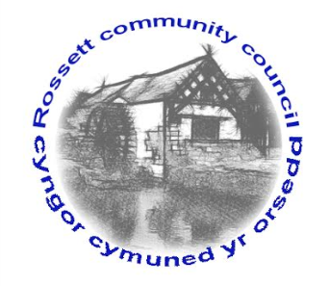

Rossett Community Council

13th December 2017

The next meeting of Rossett Community Council is to be held at Rossett Village Hall, Station Road, Rossett on Wednesday 20th December 2017 at 7.30pm to transact the following business.

Yours faithfully

Wendy Pace
Clerk for the Council

AGENDA

Declarations of Interest
Members are reminded that they should declare the existence and nature of any personal or prejudicial interest in the business of this meeting.

- Apologies for absence.

- Approval of the Minutes of the 15th November 2017 meeting.

- Police Report.

4. Representation's from General Public

5. Matters arising:

- Donation request - Rossett Scouts
- CCTV
- Mobile Post Office

7. Matters to be discussed:

(i) Electronic information storage - Clerk
(ii) Business Plan - Clerk
(iii) Upgrade of Street Lighting to LED - Cllr Morris
(iii) Clerk's Hours - Cllr Parrington

8. Reports : To receive updates from the following:

- County Councillor Jones’ Report
- Clerk’s Report
- Reports from Community Councillors

9. Planning:

P/2017/0972 - 21 Cromar Crescent, Rossett - Single storey front porch extension and two-storey Rear Extension.

P/2017/0990 - Darland High School, Chester Road, Rossett - Extension to Incorporate New Main Entrance Area and Entrance Canopy Infill Panel.

P/2017/0992 - Hansels Mead, Chapel Lane, Rossett - Parking and Operation of One Private Hire Vehicle.

10. Finance:

- Finance Report
- Invoices payable (see attached schedule)
- Donation Request - Eisteddfod
- Precept

10. Any other business

11. Date, Venue and Time of next meeting : Wednesday 17th January 2018 at 7.30pm at Rossett Presbyterian Church.

_____________________________________________________________
Clerk : Wendy Pace : clerk@rossettcommunitycouncil.cymru

