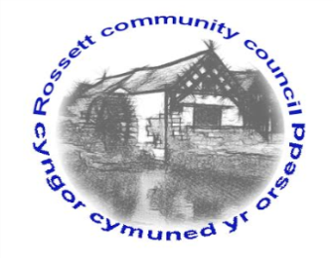

Rossett Community Council

10th January 2018

The next meeting of Rossett Community Council is to be held at Presbyterian Church meeting room, Station Road, Rossett on Wednesday 17th January 2018 at 7.30pm to transact the following business.

Yours faithfully

Wendy Pace
Clerk for the Council

AGENDA

Declarations of Interest
Members are reminded that they should declare the existence and nature of any personal or prejudicial interest in the business of this meeting.

- Apologies for absence.

- Approval of the Minutes of the 20th December 2017 meeting.

- Police Report.

4. Representation's from General Public

5. Matters arising:

- Donation request - Family Friends
- CCTV
- Cadwyn Clwyd
- Community and Town Council Review Panel
- Planning Law Changes

7. Matters to be discussed:

- River contamination

8. Reports : To receive updates from the following:

- County Councillor Jones’ Report
- Clerk’s Report
- Reports from Community Councillors

9. Planning:

P/2017/1054 - Home Farm, Gresford Road, Llay - Application for approval of reserved matters pursuant to outline planning application permission P/2014/0905 - access, appearance, landscaping, layout and scale for the erection of 362 dwellings etc

10. Finance:

- Finance Report
- Invoices payable (see attached schedule)

10. Any other business

11. Date, Venue and Time of next meeting : Wednesday 21st February 2018 at 7.30pm at Rossett Village Hall back room.

_____________________________________________________________
Clerk : Wendy Pace : clerk@rossettcommunitycouncil.cymru

