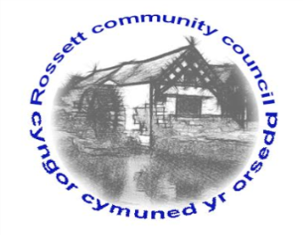

Rossett Community Council

11th February 2018

The next meeting of Rossett Community Council is to be held at Rossett Village Hall back room, Station Road, Rossett on Wednesday 21st February 2018 at 7.30pm to transact the following business.

Yours faithfully

Wendy Pace
Clerk for the Council

AGENDA

Declarations of Interest
Members are reminded that they should declare the existence and nature of any personal or prejudicial interest in the business of this meeting.

- Apologies for absence.

- Approval of the Minutes of the 17th January 2018 meeting.

- Police Report.

4. Representation's from General Public

5. Matters arising:

- CCTV
- Cadwyn Clwyd
- River contamination

7. Matters to be discussed:

- Bee Friendly Scheme
- Spring Clean – Cllr Pretsell
- CPR Training
- Community Awards

8. Reports : To receive updates from the following:

- Clerk’s Report
- Parks/Recreational Sub-Committee
- Reports from Community Councillors

9. Planning:

P/2018/0030 – Lawn House, Croeshowell Lane, Burton – Two-Storey Extenstion

P/2018/0078 – Christ Church, Chester Road – Fell /remove deadwood as per tree report

P/2018/0087 – South Bank, Station Road – Installation of replacement front windows

P/2018/0088 – Rossett Playground, Chester Road – Fell 6 trees and remove deadwood from 2

10. Finance:

- Finance Report
- Invoices payable (see attached schedule)
- Donation Requests – Rossett Swimming Club, OWL

10. Any other business

11. Date, Venue and Time of next meeting : Wednesday 21st March 2018 at 7.30pm at Rossett Presbyterian Church.

_____________________________________________________________
Clerk : Wendy Pace : clerk@rossettcommunitycouncil.cymru

