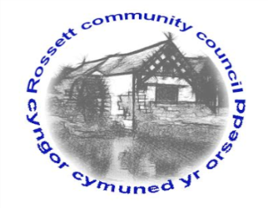

Rossett Community Council

12th March 2018

The next meeting of Rossett Community Council is to be held at Rossett Presbyterian Church Meeting room, Station Road, Rossett on Wednesday 21st March 2018 at 7.30pm to transact the following business.

Yours faithfully

Wendy Pace
Clerk for the Council

AGENDA

Declarations of Interest
Members are reminded that they should declare the existence and nature of any personal or prejudicial interest in the business of this meeting.

- Apologies for absence.

- Approval of the Minutes of the 21st February 2018 meeting.

- Police Report.

4. Representation's from General Public

5. Matters arising:

- CCTV
- Cadwyn Clwyd
- River contamination
- Post Office Outreach Service

7. Matters to be discussed:

- GDPR – Clerk
- CPR Training - Clerk
- Community Awards
- River garden – Cllr Parrington

8. Reports : To receive updates from the following:

- County Councillor Jones’ Report
- Clerk’s Report
- Reports from Community Councillors

9. Planning:

P/2018/0161 – Alndale Cottage, The Green, Rossett – Extension to form Dining/Lounge with Master Bedroom Above.

P/2018/0182 – Kingsley House, Chester Road, Lavister – Renovation of Existing Outbuilding including Increase in Height and Rear Extension.

10. Finance:

- Finance Report
- Independent Remuneration Panel for Wales
- Invoices payable (see attached schedule)

10. Other Items brought to the Council’s Attention by Councillors

11. Date, Venue and Time of next meeting : Wednesday 18th April 2018 at 7.30pm at Rossett Village Hall, back room, Station Road.

_____________________________________________________________
Clerk : Wendy Pace : clerk@rossettcommunitycouncil.cymru

