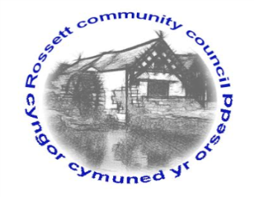

Rossett Community Council

11th April 2018

The next meeting of Rossett Community Council is to be held at Rossett Village Hall back room, Station Road, Rossett on Wednesday 18th April 2018 at 7.30pm to transact the following business.

Yours faithfully

Wendy Pace
Clerk for the Council

AGENDA

Declarations of Interest
Members are reminded that they should declare the existence and nature of any personal or prejudicial interest in the business of this meeting.

- Apologies for absence.

- Approval of the Minutes of the 21st March 2018 meeting.

- Police Report.

4. Representation's from General Public

5. Matters arising:

- CCTV
- Cadwyn Clwyd
- River contamination
- Post Office Outreach Service
- GDPR
- CPR Training
- Community Awards
- LDP Public Meeting

6. Matters to be discussed:

- River garden – Cllr Parrington
7. Reports : To receive updates from the following:

- County Councillor Jones’ Report
- Clerk’s Report
- Parks sub Committee
- Staffing Committee
- Reports from Community Councillors

8. Planning:

P/2018/0223 – Broad Oak Farm, Llyndir Lane, Rossett - Conversion of Barns (including part demolition) to form 5 No. dwellings, access arrangements and associated works.

P/2018/0231 – Land South of the Miners Welfare Institute, Llay New Road, Llay – Reserved Matters Pursuant to Outline Planning Permission P/2016/0373 – Layout, scale, appearance, landscaping for the erection of 18 No. Dwellings.

P/2018/0235 – Burton Green Cottage, Burton Green – Change of Use of Agricultural land to Residential Curtilage and Erection of Timber Frame Residential Garage.

P/2018/0237 – Rossett Lodge, The Parklands, Chester Road, Rossett – Two Storey Side Extension.

P/2018/0282 – Rackery Farm, Burton – Change of Use of Land for the Siting of 3 No. Safari Tents and Construction of Associated Parking Area.

P/2018/0303 – East View Farm, Cobblers Lane, Burton – Steel Portal Framed Agricultural Livestock Building.

P/2018/0307 – Cartref, Broad Lane, Trevalyn – Extension and Loft Conversion including raising the Ridge Height.

9. Finance:
- Finance Report
- Invoices payable (see attached schedule)

10. Other Items brought to the Council’s Attention by Councillors

11. Date, Venue and Time of next meeting: Wednesday 16th May 2018 at 7.30pm at Rossett Presbyterian Church meeting room, Station Road.
_____________________________________________________________
Clerk : Wendy Pace : clerk@rossettcommunitycouncil.cymru

