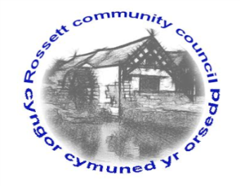

Rossett Community Council

11th July 2018

The next meeting of Rossett Community Council is to be held at Rossett Presbyterian Church meeting room, Station Road, Rossett on Wednesday 18th July 2018 at 7.30pm to transact the following business.

Yours faithfully

Wendy Pace
Clerk for the Council

AGENDA

Declarations of Interest
Members are reminded that they should declare the existence and nature of any personal or prejudicial interest in the business of this meeting.

- Apologies for absence.

- Approval of the Minutes of the 20th June 2018 meeting.

- Police Report.

4. Representation's from General Public

5. Matters arising:
- CCTV
- Cadwyn Clwyd
- CPR Training
- Community Awards
- Station Road (Burton Close) parking

7. Matters to be discussed:
- Village Festival Signs
- Poo bags - Gresford

8. Reports : To receive updates from the following:

- County Councillor Jones’ Report
- Clerk’s Report
- Reports from Community Councillors

9. Planning:

P2018/0560 – Land to the North and South of Lane Farm, Rossett – Outline Planning Application for Residential Development of Two Parcels of Land (Northern Parcel for up to 61 Dwellings, Southern Parcel for up to 71 Dwellings)

10. Finance:
- Finance Report
- Review policies – Risk assessment and Financial Regulations, Three year plan – comments received from Cllr Cleaver
- Invoices payable (see attached schedule)

11. Other Items brought to the Council’s Attention by Councillors

Cllr Matthias – Stray Cats

12. Date, Venue and Time of next meeting: Wednesday 15th August 2018 at 7.30pm at Rossett Village Hall back room, Station Road.
_____________________________________________________________
Clerk : Wendy Pace : clerk@rossettcommunitycouncil.cymru
Telephone: 07421 261118

