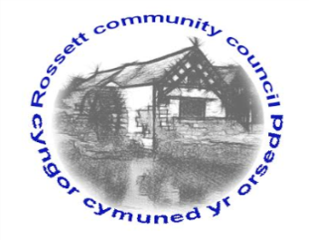

Rossett Community Council

13th June 2018

The next meeting of Rossett Community Council is to be held at Rossett Village Hall back room, Station Road, Rossett on Wednesday 20th June 2018 at 7.30pm to transact the following business.

Yours faithfully

Wendy Pace
Clerk for the Council

AGENDA

Declarations of Interest
Members are reminded that they should declare the existence and nature of any personal or prejudicial interest in the business of this meeting.

- Apologies for absence.

- Approval of the Minutes of the 16th May 2018 meeting.

- Police Report.

4. Representation's from General Public

5. Matters arising:
- CCTV
- Cadwyn Clwyd
- River contamination
- GDPR
- CPR Training
- Community Awards
- Community Councillor vacancy
- Station Road (Burton Close) parking

7. Matters to be discussed:

8. Reports : To receive updates from the following:

- County Councillor Jones’ Report
- Clerk’s Report
- Reports from Community Councillors

9. Planning:

Local Development Plan

10. Finance:
- Finance Report
- Invoices payable (see attached schedule)

11. Other Items brought to the Council’s Attention by Councillors

12. Date, Venue and Time of next meeting: Wednesday 18th July 2018 at 7.30pm at Rossett Presbyterian Church meeting room, Station Road.
_____________________________________________________________
Clerk : Wendy Pace : clerk@rossettcommunitycouncil.cymru

