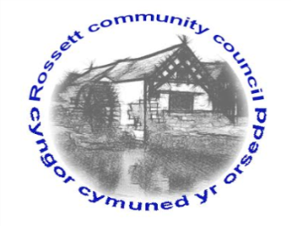

Rossett Community Council

1st August 2018

The next meeting of Rossett Community Council is to be held at Rossett Village Hall back room, Station Road, Rossett on Wednesday 15th August 2018 at 7.30pm to transact the following business.

Yours faithfully

Wendy Pace
Clerk for the Council

AGENDA

Declarations of Interest
Members are reminded that they should declare the existence and nature of any personal or prejudicial interest in the business of this meeting.

- Apologies for absence.

- Approval of the Minutes of the 18th July 2018 meeting.

- Police Report.

4. Representation's from General Public

5. Matters arising:
- CCTV
- Cadwyn Clwyd
- Community Awards
- Station Road (Burton Close) parking
- Public Meeting - WCBC proposal for traffic alterations around The Green

7. Matters to be discussed:
- Annual donation requests format - Clerk

8. Reports : To receive updates from the following:
- County Councillor Jones’ Report
- Clerk’s Report
- Reports from Community Councillors

9. Planning:

P/2018/0620 – Jasmine Cottage, Chapel Lane, Rossett – Demolition of Garage and Porch and Erection of New Single-Storey Extension to Accommodate Kitchen, Cloakroom and Hallway.

P/2018/0655 – 1 Harwoods Lane, Rossett – Erection of Part Single Storey and Part Two Storey Rear Extension.

10. Finance:
- Finance Report
- Invoices payable (see attached schedule)

11. Other Items brought to the Council’s Attention by Councillors

12. Date, Venue and Time of next meeting: Wednesday 19th September 2018 at 7.30pm at Rossett Presbyterian Church meeting room, Station Road.
_____________________________________________________________
Clerk : Wendy Pace : clerk@rossettcommunitycouncil.cymru
Telephone: 07421 261118

